#### **APPRAISAL REPORT**

|  |  |
| --- | --- |
| **CLIENT** | Estate of Ms. Catherine S. Feaga  Frederick County Register of Wills: Estate Number 52305  Robert Stauffer Feaga/Personal Representative |
| **PROPERTY ADDRESS** | 8602 Yellow Springs Road  Frederick, Maryland 21701 |
| **REPORT DATE** | July 29, 2024 |
| ***8602 Yellow Springs Road, Frederick, Maryland***  Description: Pugh Logo 2 | |

**ADDRESS/LEGAL DESCRIPTION**

8602 Yellow Springs Road

Frederick, Maryland 21701

Tax Account: 21-428426

Liber 15630/Folio 310

Tax Map 56F/Grid 4/Parcel 128

6.31 Acres Yellow Springs Road Frederick

Twenty first Election District

Frederick County, Maryland

U.S. Census Tract: 23224-24-021-7513.01

**AS OF**

**June 11, 2024**

*Retrospective Market Value*

**FOR**

Estate of Ms. Catherine S. Feaga

Frederick County Register of Wills: Estate Number 52305

Mr. Robert Stauffer Feaga

Personal Representative

8602 Yellow Springs Road

Frederick, Maryland 21701

**PREPARED BY**

Michael P. Pugh, MAI

**Copyright © 2024**

**Pugh Real Estate Group, LLC**

**Real Estate Appraisers**

**P.O. Box 378**

**Frederick, Maryland 21705**

Pugh Real Estate Group, LLC

real estate appraisers

post Office box 378

frederick, maryland 21705

(301) 898-1178

[www.PughRealEstateGroup.com](http://www.PughRealEstateGroup.com)

July 30, 2024

Estate of Ms. Catherine S. Feaga

Frederick County Register of Wills: Estate Number 52305

Mr. Robert S. Feaga

Personal Representative

8602 Yellow Springs Road,

Frederick, MD 21701

Re: 8602 Yellow Springs Road,

Frederick, MD 21701

Dear Mr. Feaga:

Recently, you asked me to provide you with a retrospective market value for the property identified above. This appraisal report provides an opinion of value as of June 11, 2024, which is the date of death of Ms. Catherine S. Feaga. The attached appraisal report provides essential data and detailed reasoning employed in reaching my opinion of value.

**SUMMARY OF SITE, ZONING, AND IMPROVEMENTS**

The subject property includes one lot totaling 6.29 acres or 273,992 square feet of land. The property is located on the west side of Yellow Springs Road.

The subject property is improved with a two-story single-family house with 2,584 square feet of gross living area. This house was constructed in 1987.

The subject property is zoned Agricultural (A) by the Frederick County Planning Department. The purpose of the Agricultural District (A) is to preserve productive agricultural land and the character and quality of the rural environment and to prevent urbanization where roads and other public facilities are scaled to meet only rural needs.

The subject property is not currently listed for sale.

**EXTRAORDINARY ASSUMPTIONS**

Uniform Standard of Professional Appraisal Practice (USPAP) defines an Extraordinary Assumption as, “an assumption, directly related to a specific assignment, as of the effective date of the assignment result, which, if found to be false, could alter the appraiser’s opinions or conclusions.”

*No extraordinary assumptions were considered for this assignment.*

**HYPOTHETICAL CONDITIONS**

USPAP defines a Hypothetical Condition as, “that which is contrary to what is known the appraiser to exist on the effective date of the assignment results but is used for the purpose of analysis.”

*No hypothetical conditions were considered for this assignment.*

**VALUATION SUMMARY**

After careful consideration of all the factors which create value, it is my opinion that the subject property has a value as follows:

|  |  |  |  |
| --- | --- | --- | --- |
| **VALUE TYPE** | **INTEREST APPRAISED** | **DATE OF VALUE** | **VALUE** |
| Retrospective Market Value | *Fee Simple* | *June 11, 2024* | *$710,000* |

If you have any questions concerning this appraisal or the value conclusions developed in this report, please do not hesitate to contact me.

Sincerely,

|  |  |  |
| --- | --- | --- |
| |  | | --- | | mike sign  **Michael P. Pugh, MAI**  **Certified General Real Estate Appraiser**  **State of Maryland – License No. 04-29481**  **Washington D.C. – License No. GA40000137** | |  |

**Table of Contents**

SUMMARY OF IMPORTANT FACTS AND CONCLUSIONS 6

CERTIFICATE OF APPRAISAL 7

SCOPE OF THE APPRAISAL 9

ASSUMPTIONS & LIMITING CONDITIONS 10

KEY TERMS FOR THIS APPRAISAL ASSIGNMENT 12

IDENTIFICATION OF THE SUBJECT PROPERTY 14

SUBJECT PROPERTY HISTORY 17

REGIONAL DATA 18

REAL ESTATE TAX ANALYSIS 31

MARKET ANALYSIS 32

ZONING 37

SITE DATA 42

DESCRIPTION OF IMPROVEMENTS 46

PHOTOGRAPHS OF THE SUBJECT PROPERTY 50

HIGHEST AND BEST USE 64

VALUATION METHODOLOGY 68

Site Valuation 69

COST APPROACH TO VALUE 75

INCOME CAPITALIZATION APPROACH 80

SALES COMPARISION APPROACH 82

RECONCILIATION OF VALUE INDICATIONS 88

**ADDENDUM:**

APPRAISER QUALIFICATIONS

ENGAGEMENT LETTER

|  |  |  |
| --- | --- | --- |
| SUMMARY OF IMPORTANT FACTS AND CONCLUSIONS | | |
| **Address** | 8602 Yellow Springs Road  Frederick, Maryland 21701 | |
| **Date of Value Estimate** | |  | | --- | | June 11, 2024 Retrospective Market Value | | |
| **Appraisal**  **Report Date** | July 30, 2024 | |
| **Property Rights Appraised** | Fee Simple | |
| **Land Area** | The subject property includes one lot totaling 6.29 acres or 273,992 square feet of land. | |
| **Improvements** | The subject property is improved with a two-story single-family house with 2,584 square feet of gross living area. This house was constructed in 1987. | |
| **Zoning/Governance** | The subject property is zoned Agricultural (A) by the Frederick County Planning Department. | |
| **Intended Use** | Estate Settlement. No other uses are permitted. | |
| **Client/Intended User** | Estate of Ms. Catherine S. Feaga. | |
| **HIGHEST AND BEST USE** | | |
| **As Vacant** | Residential. | |
| **As Improved** | Continued use as improved. | |
| **VALUATION** | | |
| Retrospective market value as of June 11, 2024 | | Site Valuation Abandoned  Cost Approach Abandoned  Sales Comparison Approach $410,000  Income Capitalization Abandoned  Reconcile Value $410,000 |

# CERTIFICATE OF APPRAISAL

I certify that, to the best of my knowledge and belief:

1. The statements of fact contained in this report are true and correct.
2. The reported analyses, opinions, and conclusions are limited only by the reported assumptions and limiting conditions and are my personal, impartial, and unbiased professional analyses, opinions, and conclusions.
3. I have no present or prospective interest in the property that is the subject of this report and no personal interest with respect to the parties involved.
4. We have not appraised this property in the past three years.
5. I have no bias with respect to the property that is the subject of this report or to the parties involved with this assignment.
6. My engagement in this assignment was not contingent upon developing or reporting predetermined results.
7. My compensation for completing this assignment is not contingent upon the development or reporting of a predetermined value or direction in value that favors the cause of the client, the amount of the value opinion, the attainment of a stipulated result, or the occurrence of a subsequent event directly related to the intended use of this appraisal.
8. My analyses, opinions, and conclusions were developed, and this report has been prepared, in conformity with the Uniform Standards of Professional Appraisal Practice.
9. I have made a personal inspection of the property that is the subject of this report.
10. No one provided significant real property appraisal assistance to the person signing this certification.
11. The reported analyses, opinions, and conclusions were developed, and this report has been prepared in conformity with the Code of Professional Ethics and Standards of Professional Appraisal Practice of the Appraisal Institute.
12. The use of this report is subject to the requirements of the Appraisal Institute relating to review by its duly authorized representatives.
13. As of the date of this report, I have completed the Standards and Ethics Education Requirement of the Appraisal Institute for Designated Members.

|  |  |  |
| --- | --- | --- |
| |  | | --- | | mike sign  **Michael P. Pugh, MAI**  **Certified General Real Estate Appraiser**  **State of Maryland – License No. 04-29481**  **Washington D.C. – License No. GA40000137** | |  |

**MARYLAND REGISTER, VOL. 17**

**RULES GOVERNING SETTLEMENT OF DECEDENT'S ESTATES**

**RULE 6‑403. APPRAISAL**

**CERTIFICATION**

In re: Estate of Ms. Catherine S. Feaga

I solemnly affirm under the penalties of perjury that I appraised the property listed in this appraisal effective on June 11, 2024 and the appraisal was done impartially and to the best of my skill and judgment.

The above date is the date of death with the inspection having occurred subsequent to that date.

|  |
| --- |
| **Michael P. Pugh, MAI**  **Certified General Real Estate Appraiser**  **State of Maryland – License No. 04-29481** |

|  |  |
| --- | --- |
| SCOPE OF THE APPRAISAL | |
| Real estate is valued based using the following techniques – Site Valuation, Cost, Income and Sales Comparison Approaches – which are defined below: | |
| **SITE VALUATION** | This approach to value is the estimation of value of a subject site, as vacant and ready to be improved, based upon factual data extracted from sales of similar or reasonably similar properties. |
| **COST** | This approach to value is utilized to reflect the value of the property by adding together the estimated value of the land, as vacant, and the reproduction cost new of the improvements, less the accrued depreciation. |
| **INCOME CAPITALIZATION APPROACH** | This approach estimates value by the capitalization of the net income stream. |
| **SALES COMPARISON APPROACH** | This approach to value is the estimation of value of a subject property based upon factual data extracted from sales of similar or reasonably similar properties. |
| The scope of work used in preparing this appraisal is included throughout this report in the various descriptions and analysis. The following bullet points give a general overview of the scope of work, while more detailed descriptions are included in the appropriate sections of the report. The general scope is shown below:   * Michael Pugh and Jack Molesworth inspected the subject property on July 17, 2024. The scope of the inspection included the site, improvements noted in this report, and the surrounding area. * Gathered and analyzed data on comparable improved sales in the market area from the Maryland Department of Assessment and Taxation, CoStar, and MRIS; * Spoke with realtors engaged in the market-place within the subject area as to the sale, leasing, and marketing times for similar type properties; * Reviewed data of similar property sales in both MRIS and CoStar to verify the competitive environment of properties that are offered for sale that have similar characteristics as the subject property; * Reviewed material from Frederick County Planning Department in regards to the subject property zoning and surrounding area; * Reported results using USPAP prescribed content for an appraisal report; * It is important to note that the opinion of value provided in this report is based on the assumption that the property is not negatively affected by the existence of hazardous substances or other environmental conditions. * Real Estate Appraisers are not experts in the identification of hazardous substances or other environmental conditions. During the property inspection and inquiries of the subject site, the appraisers did not become aware of any information that would lead to the conclusion that any negative environmental conditions exist on the subject property. | |

# ASSUMPTIONS & LIMITING CONDITIONS

* Unless otherwise stated, the value appearing in this appraisal represents the opinion of the Market Value or the Value Defined as of the date specified. Market Value of real estate is affected by national and local economic conditions and, consequently, will vary with future changes in such conditions.
* The value estimated in this appraisal report is gross, without consideration given to any encumbrance, restriction or question of title, unless specifically defined.
* The value is reported in dollars on the basis of the currency prevailing at the date of appraisal.
* This appraisal report covers only the property described and any values or rates utilized are not to be construed as applicable to any other property, however similar the properties might be.
* It is assumed that the title to the premises is good, that the legal description is correct, that the improvements are entirely and correctly located on the property described, and that there are no encroachments on this property. However, no investigation or survey has been made.
* This appraisal expresses my opinion, and the employment to make this appraisal was in no way contingent upon the reporting or predetermined value or conclusion.
* No responsibility is assumed for matters legal in nature, nor is any opinion of title rendered. In the performance of my investigation and analysis leading to the conclusions reached herein, the statements of others were relied on.
* Neither all nor any part of the contents of this report (especially any conclusions, the identity of the appraiser or the firm with which he is connected, or any reference to the Appraisal Institute or any of its designations) shall be disseminated to the public through advertising media, public relations media, news media, sales media or any other public means of communication without my prior written consent and approval.
* It is assumed that there are no hidden or unapparent conditions of the property, subsoil, or structures which would render it more or less valuable. The Appraiser assumes no responsibility for such conditions or the engineering which might be required to discover these factors.
* Unless otherwise stated in this report, the existence of hazardous substances, including without limitation asbestos, polychlorinated biphenyls, petroleum leakage, or agricultural chemicals, which may or may not be present on the property, or other environmental conditions, were not called to the attention of the appraiser, nor did the appraiser become aware of such during the appraiser's inspection. The appraiser has no knowledge of the existence of such materials on or in the property unless otherwise stated. The appraiser, however, is not qualified to test for such substances or conditions. If the presence of such substances, such as asbestos, formaldehyde foam insulation, or other hazardous substances or environmental conditions, may affect the value of the property, the value estimated is predi­cated on the assumption that there is no such proximity thereto that would cause a loss in value. No responsibility is assumed for any such conditions, nor for any expertise or engineering knowledge required to discover them.
* All mortgages, liens, encumbrances, leases, and servitudes have been disregarded unless so specified within the report. The property is appraised as though under responsible ownership and competent management.
* It is assumed that there is full compliance with all applicable federal, state and local environmental regulations and laws unless noncompliance is stated, defined and considered in the appraisal report.
* It is assumed that all required licenses, consents or other legislative or administrative authority from any local, state or national government or private entity or organization have been or can be obtained or renewed for any use on which the value estimate contained in this report is based. It is assumed that a permit for the construction of the entire entity is in place.
* It is assumed that the subject property and the market data used within this report does not have a level of Radon in excess of the limits established by the Environmental Protection Agency (EPA).
* The appraiser will not be required to give testimony or appear in court because of having made this appraisal unless previous arrangements are made with the appraiser prior to the writing of the report.
* As far as residential multi-unit dwellings are concerned, i.e., the reader should be informed that the undersigned appraiser does not have the expertise or experience to visualize the presence of any form of lead based paint. Consequently, no responsibility for the presence of lead based paint or the effect of its presence in the subject property is assumed by this appraiser. If a property owner has informed this appraiser by written instrument of the presence of lead based paint within the subject property, a copy of this letter and consideration for its effect on value will be dealt with within the report.
* Assumed that live and dead loads within the structure do not exceed the design feature of the building.
* Assumed that the soils on the subject site will support the building improvements currently located on the site.
* Assumed that subject property owners have all appropriate permits and licenses required to operate the existing business. In addition, I assume that the subject property owners have the requisite management expertise for the continued operation of their business.
* Pertaining to the Americans with Disabilities Act (ADA), we have not made a specific compliance survey and analysis of this property to determine whether or not it is in conformity with the various detailed requirements of the ADA. It is possible that a compliance survey of the property together with a detailed analysis of the requirements of the ADA could reveal that the property is not in compliance with one or more of the requirements of the act. If so, this fact could have a negative effect upon the value of the property. Since we have no direct evidence relating to this issue, we did not consider possible noncompliance with the requirements of ADA in estimating the value of the property.
* This appraisal report was completed without the benefit of a title report.  It is assumed that the title to the premises is good, that the legal description is correct, that the improvements are entirely and correctly located on the property described, and that there are no encroachments on this property other than what is noted in the report.
* The property deed was used as reference to determine/verify the site size and dimensions and it was assumed to be an accurate representation of the subject site.  A formal survey was not completed as part of this assignment.
* This report was completed without the benefit of analysis from a structural engineer.
* The valuation reflected does not include personal property.

|  |  |
| --- | --- |
| KEY TERMS FOR THIS APPRAISAL ASSIGNMENT | |
| **APPRAISAL REPORT** | The content of an Appraisal Report must be consistent with the intended use of the appraisal and, at a minimum: (i) state the identity of the client and any intended users, by name or type; (ii) state the intended use of the appraisal; (iii) summarize information sufficient to identify the real estate involved in the appraisal, including the physical, legal, and economic property characteristics relevant to the assignment; (iv) state the real property interest appraised; (v) state the type and definition of value and cite the source of the definition; (vi) state the effective date of the appraisal and the date of the report; (vii) summarize the scope of work used to develop the appraisal; (viii) summarize the information analyzed, the appraisal methods and techniques employed, and the reasoning that supports the analyses, opinions, and conclusions; exclusion of the sales comparison approach, cost approach, or income approach must be explained; (ix) state the use of the real estate existing as of the date of value and the use of the real estate reflected in the appraisal; (x) when an opinion of highest and best use was developed by the appraiser, summarize the support and rationale for that opinion; (xi) clearly and conspicuously:  state all extraordinary assumptions and hypothetical conditions; and state that their use might have affected the assignment results; and (xii) include a signed certification in accordance with Standards Rule 2-3. |
| **PROPERTY RIGHTS APPRAISED** | **Fee Simple Estate.** *Absolute ownership unencumbered by any other interest or estate, subject only to the limitations imposed by the governmental powers of taxation, eminent domain, police power, and escheat.[1]* |
| **DEFINITION OF MARKET VALUE** | The most probable price which a property should bring in a competitive and open market. Conditions requisite to a fair sale, the buyer and seller each acting prudently, knowledgeably, and assuming the price is not affected by undue stimulus. Implicit in this definition is the consummation of a sale whereby: 1) Buyer and seller are typically motivated; (2) Both parties are well informed or well advised, and acting in what they consider their own best interests; (3) A reasonable time is allowed for exposure in the open market; (4) Payment is made in terms of cash in U.S. dollars or in terms of financial arrangement comparable thereto; and, (5) The price represents the normal consideration for the property sold unaffected by special or creative financing or sales concessions granted by anyone associated with the sale.[2] |
| **EXPOSURE AND MARKETING TIME** | Exposure time as used in this appraisal report is defined as:  **Exposure time.** *The estimated length of time the property interest being appraised would have been offered on the market prior to the hypothetical consummation of a sale at market value on the effective date of the appraisal; a retrospective estimate based on an analysis of past events assuming a competitive and open market.*  Based upon the market data from the sales of comparable properties in the market my conclusion of exposure time follows:  Conclusion:  Exposure Time One to Three Months  **Marketing time.** *The time it takes an interest in real property to sell on the market subsequent to the date of appraisal.*  Based upon the market data from the sales of comparable properties in the market my conclusion of exposure time follows:  Conclusion:  Marketing Time One to Three Months |

|  |  |
| --- | --- |
| IDENTIFICATION OF THE SUBJECT PROPERTY | |
| **PROPERTY**  **ADDRESS** | 8602 Yellow Springs Road  Frederick, Maryland 21701 |
| **LEGAL**  **DESCRIPTION** | Tax Account: 21-428426  Liber 15630/Folio 310  Tax Map 56F/Grid 4/Parcel 128  6.31 Acres Yellow Springs Road Frederick  Twenty first Election District  Frederick County, Maryland  U.S. Census Tract: 23224-24-021-7513.01 |
| **SUBJECT PROPERTY SUMMARY** | The subject property includes one lot totaling 6.29 acres or 273,992 square feet of land. The property is located on the west side of Yellow Springs Road.  The subject property is improved with a two-story single-family house with 2,584 square feet of gross living area. The house was constructed in 1987 and includes a driveway and a detached garage with three vehicle spaces for parking.  The subject property is zoned Agricultural (A) by the Frederick County Planning Department. The purpose of the Agricultural District (A) is to preserve productive agricultural land and the character and quality of the rural environment and to prevent urbanization where roads and other public facilities are scaled to meet only rural needs. |
| **TAX MAP** |  |
| **SUBJECT PHOTO -- RESIDENCE** |  |
| **STORAGE BUILDING** |  |
| **AERIAL VIEW** |  |

# SUBJECT PROPERTY HISTORY

Catherine S. Feaga was made the sole owner of the subject property on December 20, 2021. This transaction was recorded under Liber 15630 Folio 310 of the Frederick County land records.

# REGIONAL DATA

**Summary & Location**

Frederick County is Maryland's largest county in size -- 663 square miles. The City of Frederick, the county seat, is intersected by five interstate and national highways that provide easy access to Baltimore (46 miles), Washington D.C. (44 miles), Gettysburg, PA (32 miles), Harpers Ferry, West Virginia (21 miles), and Leesburg, Virginia (25 miles). It is home to the 5,700-acre Catoctin Mountain Park, site of the Camp David Presidential Retreat. Frederick County is also Maryland's largest dairy producer and has the second largest concentration of biotech companies in the state, with over 80 biotech firms located within Frederick County. The following chart reflects driving distance from Frederick to key U.S. Cities:



**Regional View**



**Transportation & Linkages**

***Highways:*** Interstate 70, Interstate 270, U.S. Route 15, and U.S. Route 340.

***Mass Transit:*** MARC (commuter rail) service to Washington D.C. and Amtrak; public bus transportation throughout Frederick City and connecting other municipalities.

***Rail:*** CSX Transportation and Maryland Midland Railway (short line service).

***Truck:*** 76 local and long-distance trucking establishments are located in the county.

***Water:*** Served by the Port of Baltimore, 50' channel; a leading U.S. automobile and break-bulk port; seven public terminals including the state-of-the-art Intermodal Container Transfer Facility.

***Air:*** Served by Baltimore/Washington International Thurgood Marshall Airport (BWI); Reagan Washington National Airport; and Dulles International Airport. Frederick Municipal Airport offers jet and turboprop charter service and has two runways.

**Population**

Desirable living conditions have contributed to Frederick County being among the fastest growing counties in the region. From 2000 to 2010, Frederick County experienced a 19.2% increase in population while the State of Maryland's total population increased by 9% during the same time frame. According to U.S. Census, the 2020 population for Frederick County was 271,717, which is approximately 16.4% over the 2010 Census. The estimated population for 2022 was 287,079. Please note the following table (Source: U.S. Census):

|  |  |  |  |  |
| --- | --- | --- | --- | --- |
| **FREDERICK COUNTY: POPULATION PROFILE** | | | | |
|  | **2000** | **2010** | **2020** | **2022** |
| **Population** | **195,277** | **233,385** | **271,717** | **287,079** |

From 2010 to 2020, Frederick City experienced a 19.73% increase in population which is slightly higher than the rate noted for Frederick County The census population in 2020 was 78,171. The estimated population for 2022 was 82,175. Please note the following table (Source: U.S. Census):

|  |  |  |  |  |
| --- | --- | --- | --- | --- |
| **FREDERICK CITY: POPULATION PROFILE** | | | | |
|  | **2000** | **2010** | **2020** | **2022** |
| **Population** | **52,767** | **65,289** | **78,171** | **82,175** |

Below is a chart showing the estimated population growth for the municipalities in Frederick County, from the 2010 U.S. Census to 2020:

|  |  |  |  |  |
| --- | --- | --- | --- | --- |
|  | **Population** | **Population** | **Estimated Growth** | **Estimated** |
| **City/Town** | **per 2010 Census** | **Per 2020 Census** | **Since 2010** | **Percent Increase** |
| **Brunswick** | 5,870 | 7,762 | 1,892 | 32.23% |
| **Burkittsville** | 151 | 151 | 0 | 0.00% |
| **Emmitsburg** | 2,814 | 3,156 | 342 | 0.00% |
| **Frederick** | 65,239 | 78,171 | 12,932 | 6.77% |
| **Middletown** | 4,136 | 4,943 | 807 | 6.71% |
| **Mt. Airy** | 9,288 | 9,654 | 366 | .93% |
| **Myersville** | 1,626 | 1,763 | 137 | 5.08% |
| **New Market** | 656 | 1,536 | 880 | 43.88% |
| **Rosemont** | 294 | 272 | 18 | 0.00% |
| **Thurmont** | 6,170 | 6,274 | 104 | 0.88% |
| **Walkersville** | 5,800 | 6,261 | 461 | 1.81% |
| **Woodsboro** | 1,141 | 1,181 | 40 | 0.87% |
|  | |  |  |  |

**Income**

According to U.S. Census, Frederick County’s median household income in 2020 was $97,730 which was 15% greater than the state of Maryland’s average of $84,805. Maryland had the highest median household income of any state in the U.S. according to the 2020 Census. The estimated median household income in 2022 was $115,724. The following information, obtained from the City of Frederick’s Office of Economic Development website, reflects the income data for Frederick County:

|  |  |  |  |  |  |  |
| --- | --- | --- | --- | --- | --- | --- |
| **Households by Income** | **2000** | | **2010** | | **2020** | |
| **Number** | **%** | **Number** | **%** | **Number** | **%** |
| <$15,000 | 5,014 | 7.2 | 4,116 | 4.9 | 4,339 | 4.7 |
| $15,000-$24,999 | 5,519 | 7.9 | 4,765 | 5.6 | 3,080 | 3.3 |
| $25,000-$34,999 | 6,554 | 9.3 | 4,507 | 5.3 | 4,131 | 4.4 |
| $35,000-$49,999 | 11,063 | 15.8 | 9,294 | 11.0 | 8,508 | 9.2 |
| $50,000-$74,999 | 16,815 | 24.0 | 17,466 | 20.7 | 13,761 | 14.9 |
| $75,000-$99,999 | 11,846 | 16.9 | 16,809 | 19.9 | 13,309 | 14.4 |
| $100,000-$149,000 | 9,495 | 13.5 | 18,339 | 21.7 | 21,473 | 23.2 |
| $150,000-$199,999 | 2,253 | 3.2 | 5,791 | 6.9 | 13,775 | 14.9 |
| $200,000+ | 1,556 | 2.2 | 3,431 | 4.1 | 9,921 | 10.7 |
|  | | | | | | |
| Median HH Income | $60,256 | | $77,242 | | $97,730 | |
| Average HH Income | $69,955 | | $88,872 | | $117,009 | |

Median household income for Frederick County increased over 28% between 2000 and 2010. Estimates for 2020 showed a 27% increase in median household income since 2010.

The median household income for Frederick City for 2020 was $74,801 (esri community profile) The estimated median income for 2022 according to census data was $89,981. The following chart, obtained from the City of Frederick’s Office of Economic Development website, reflects the income data for Frederick City:

|  |  |  |  |  |  |  |
| --- | --- | --- | --- | --- | --- | --- |
| **Households by Income** | **2000** | | **2010** | | **2020** | |
| **Number** | **%** | **Number** | **%** | **Number** | **%** |
| <$15,000 | 2,156 | 10.3 | 1,826 | 7.2 | 1,902 | 6.5 |
| $15,000-$24,999 | 2,275 | 10.9 | 2,128 | 8.4 | 1,756 | 6.0 |
| $25,000-$34,999 | 2,646 | 12.7 | 1,948 | 7.7 | 1,610 | 5.5 |
| $35,000-$49,999 | 3,864 | 18.5 | 3,654 | 14.5 | 4,537 | 15.5 |
| $50,000-$74,999 | 4,861 | 23.3 | 5,757 | 22.8 | 4,859 | 16.6 |
| $75,000-$99,999 | 2,678 | 12.8 | 4,622 | 18.3 | 4,098 | 14 |
| $100,000-$149,000 | 1,779 | 8.5 | 3,782 | 15.0 | 5,445 | 18.6 |
| $150,000-$199,999 | 360 | 1.7 | 900 | 3.6 | 2,605 | 8.9 |
| $200,000+ | 270 | 1.3 | 627 | 2.5 | 2,459 | 8.4 |
|  | | | | | | |
| Median HH Income | $47,793 | | $61,794 | | $74,801 | |
| Average HH Income | $57,064 | | $72,842 | | $98,516 | |

Median household income for Frederick City increased more than 29% between 2000 and 2010. Data for 2020 show a 21% increase in median household income since 2010.

**Labor & Employment**

The labor market of Frederick County also includes portions of other surrounding counties within the State of Maryland, as well as Loudoun County, Virginia; Adams County, Pennsylvania; and Jefferson County, West Virginia.

The Maryland Department of Labor reported that Frederick County's 2020 average unemployment rate was up significantly from 2019 numbers, due in large part to the effects of the pandemic. The first and second quarter 2020 rates were negatively impacted significantly by the CoVid-19 pandemic, reaching 9.8% as of end April 2020). At the end of 2019, the rate was 2.6% in December, compared to 5.0% in December 2020. The unemployment rate continued to decrease in 2021 to end the year at 3.4% in December 2021 (source: U.S. Bureau of Labor Statistics, St. Louis Federal Reserve). The unemployment rate by December 2022 was 2.80%.

The workforce includes the population of Frederick County between the ages (living in Frederick County, not necessarily working in Frederick County) of 18 and 65.

|  |  |  |  |  |
| --- | --- | --- | --- | --- |
| **Frederick County Labor Force Estimates** | | | | |
|  | | | | |
| **YEAR** | **Labor Force** | **Employment** | **Unemployment** | **Rate** |
| 2022* | 137,124 | 133,256 | 3,868 | 2.80% |
| 2021 | 131,270 | 126,807 | 4,463 | 4.80% |
| 2020 | 129,790 | 123,289 | 6,501 | 5.80% |
| 2019 | 135,685 | 131,633 | 3,564 | 3.00% |
| 2018 | 132,005 | 127,484 | 4521 | 3.20% |
| 2017 | 131,266 | 126,505 | 4,761 | 3.50% |
| 2016 | 129,440 | 124,587 | 4,853 | 3.80% |
| 2015 | 128,775 | 123,006 | 5,769 | 4.50% |
| 2014 | 128,018 | 121,547 | 6,471 | 5.10% |
| 2013 | 128,357 | 120,947 | 7,410 | 5.80% |
| 2012 | 128,605 | 120,756 | 7,849 | 6.10% |

Source: U.S. Bureau of Labor Statistics, St. Louis Federal Reserve

*December 2022

The following chart highlights employment and payrolls by industry within Frederick County – representing the labor force working in Frederick County regardless of where they live (in or out of county). Based on information collected since 2011 through 2020, this chart reflects employment in Frederick County[3] segmented by government, private sector and within private sector by industry breakdown:

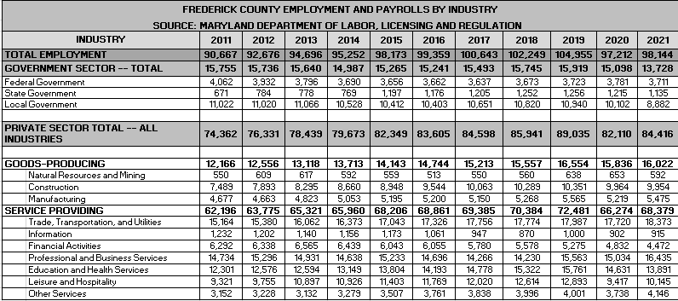

The total number of people employed in Frederick County increased for nine consecutive years between 2011 and 2019. 2020 saw a significant decrease due to the negative impact of the Covid 19 pandemic on the economy. Please note the following chart:

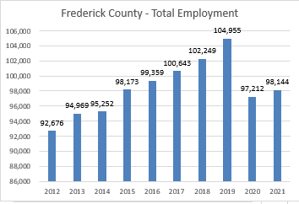

Between 2011 and 2021, the overall government sector employment experienced only modest growth – 15,755 persons in 2011 as compared to 15,913 in 2019. However, the sector shrunk significantly between 2019 and 2021. The number of federal employees declined from 4,062 in 2011 to 3711 in 2021.. However, state government employees increased from 671 in 2011 to 1,135 in 2021 -- representing an 69% increase. Local/municipal employment in Frederick County decreased from 11,022 in 2011 to 10,102 in 2021 – an 8% decrease.

Frederick County’s private sector employment saw increases during the same time period (2011-2019). As with overall employment, private sector employment increased eight consecutive years – increasing by approximately 16.64% -- during this time frame. Again, 2020 saw a significant decrease due to the effects of the pandemic. It rebounded modestly in 2021. Please note the following chart:

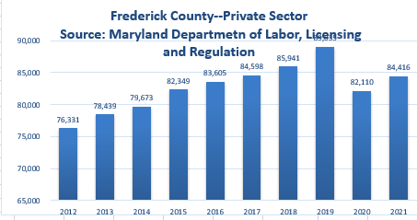

Key drivers of private sector employment growth since 2011 have been increases in the number of people working in the service providing sectors which represent over 78% of the increases since 2011. Eliminating the increases in construction (2,471) from the goods producing sectors provides a net increase of 840 jobs which is just over five percent of the total private sector increases. Please note the following chart:

|  |  |  |
| --- | --- | --- |
| **Area** | | **Net Increase (Decrease)** |
| **Goods Producing** | | **3,311** |
|  | Natural Resources and Mining | 42 |
|  | Construction | 2471 |
|  | Manufacturing | 798 |
| **Service Providing** | | **12,181** |
|  | Trade, Transportation, and Utilities | 3209 |
|  | Information | (317) |
|  | Financial Activities | (1,820) |
|  | Professional and Business Services | 1701 |
|  | Education and Health Services | 1590 |
|  | Leisure and Hospitality | 6824 |
|  | Other Services | 994 |
| **Total Private Sector Increases** | | **15,492** |

Areas of private sector decline include financial activities and information, the result of continuing consolidation in each of these industries. The following chart reflects the top employers in Frederick County, according to the Frederick County Office of Economic Development, 2019:

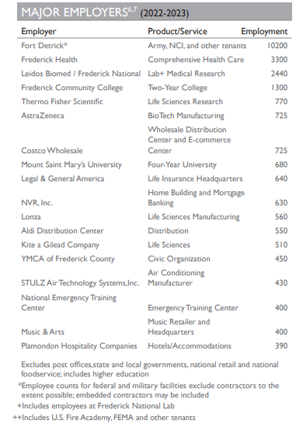

Source: Maryland Department of Commerce, Brief Economic Facts, Frederick County, Maryland

**Housing**

In 2022 Frederick County had a total of 99,891 households with an average household size of 2.7.[4] Frederick City had a total of 106,417 housing units estimated in 2021. The median value of a home in Frederick County in 2021 was $356,500 and in Frederick City $289,000 (2021).

**Frederick County Government**

Frederick County transitioned from the County Commissioner form of government to the County Charter form of government on December 1, 2014.  Under Charter Government, there is an Executive Branch with a County Executive and a Legislative Branch with a County Council.

The County Executive establishes the long-term vision for Frederick County and ensures effective and efficient services to county residents.  The County Executive provides management oversight and direction for Frederick County Government departments and agencies, establishes public policy, and is responsible for the development of the county budget. The County Executive serves a four-year term and not more than two consecutive terms.

The seven-member County Council consists of five members elected by district and two elected at large. They also serve four-year terms -- no more than three consecutive terms. Council members will have the power to initiate legislation.

Frederick County has twelve municipalities: [Brunswick](http://msa.maryland.gov/msa/mdmanual/37mun/brunswick/html/b.html), [Burkittsville](http://msa.maryland.gov/msa/mdmanual/37mun/burkittsville/html/b.html), [Emmitsburg](http://msa.maryland.gov/msa/mdmanual/37mun/emmitsburg/html/e.html), [Frederick](http://msa.maryland.gov/msa/mdmanual/37mun/frederick/html/f.html), [Middletown](http://msa.maryland.gov/msa/mdmanual/37mun/middletown/html/m.html), [Mount Airy](http://msa.maryland.gov/msa/mdmanual/37mun/mountairy/html/m.html), [Myersville](http://msa.maryland.gov/msa/mdmanual/37mun/myersville/html/m.html), [New Market](http://msa.maryland.gov/msa/mdmanual/37mun/newmarket/html/n.html), [Rosemont](http://msa.maryland.gov/msa/mdmanual/37mun/rosemont/html/r.html), [Thurmont](http://msa.maryland.gov/msa/mdmanual/37mun/thurmont/html/t.html), [Walkersville](http://msa.maryland.gov/msa/mdmanual/37mun/walkersville/html/w.html), and [Woodsboro](http://msa.maryland.gov/msa/mdmanual/37mun/woodsboro/html/w.html). Frederick was the first locality to incorporate in Frederick County in 1816. It was followed by Emmitsburg (1824), Thurmont (1831), Middletown (1833), Woodsboro (1836), New Market (1878), Brunswick (1890), Walkersville (1892), Burkittsville (1894), Mount Airy (1894), Myersville (1904), and Rosemont (1953).

**Economic Development**

The City of Frederick Department of Economic Development is an active organization tasked with increasing economic opportunities for Frederick residents through job creation, revitalization, and reinvestment. This mission is achieved through four strategic priorities: job creation, business infrastructure advocacy, downtown revitalization, and key corridor revitalization.

Business attraction and retention is a core function of DED. The City works in partnership with Frederick County Business Development and Retention Department (BDRD) and the Maryland Department of Business and Economic Development (DBED), to attract business to Frederick. Outreach efforts include regional and national trade shows targeted at bioscience and technology; targeted regional advertising that focuses on bioscience, technology, manufacturing and site selection consultants; and participation in and sponsorship of key industry events hosted by groups such as the Tech Council of Maryland and Maryland/DC Chapter of NAIOP.

Business retention and expansion is a key focus. Studies by the International Economic Development Council (IEDC) show that 65-80% of new jobs in a community are created by the existing businesses. Retention and expansion efforts include business retention visits; attendance at local business events such as the Frederick County Chamber of Commerce activities; local advertising and trade shows; and support for expanding businesses as they navigate the development review and permit process.

Downtown Frederick, serving as the County Seat, is home to more than 600 businesses and 5,000 employees. Downtown is also the hub of culture and tourism, attracting more than 1.4 million visitors annually. As a major economic engine within the City, continued revitalization, reinvestment and adaptive reuse of historic buildings are key economic development goals for DED.

The City's retail and business corridors also serve as valuable economic engines. Revitalization and reinvestment in traditional retail corridors and the surrounding neighborhoods are critical DED initiatives that strengthen both the business community and quality of life in Frederick.

**Education**

Frederick County offers a wide variety of public and private educational opportunities for its residents – which include pre-primary through graduate school. Frederick County is nationally recognized for its public education system and remains one of the region's leaders in virtually every measure of student achievement and educational attainment. [Frederick County Public Schools (FCPS)](http://www.fcps.org) has been a recipient for many years of the US Department of Education's prestigious national Blue Ribbon Schools of Excellence Award and Maryland Public Schools rank first in the Nation for the 4th year in a row in 2011 by Education Week Magazine. Also in 2011, Michelle Shearer, an Urbana High School Teacher and FCPS employee was named National Teacher of the Year.

**2023 Frederick County Public School Statistics:**

* Total Enrollment – 46,889
* Total Schools - 69
  + 38 Elementary
  + 13 Middle
  + 10 High
  + 8 Special
* Graduation Rate – 93%
* Dropout Rate – 2.6%

***Source:*** [***March 2023- Frederick County Public School***](http://fcps.schoolwires.com/fcps/lib/fcps/publications/FCPSwinter09_10.pdf)***s (FCPS.org)***

**Private Schools**

* [The Banner School](http://www.bannerschool.org), Frederick
* [The Barnesville School](http://www.barnesvilleschool.org), Frederick
* [Beth Sholom Day School](http://www.bethsholomfrederick.org), Frederick
* Catoctin View Mission School, Thurmont
* [Frederick Adventist School](http://fredericksdachurch.org), Frederick
* [Frederick Christian Academy](http://www.fcamd.org), Frederick
* Frederick Montessori School, Frederick
* [Friends Meeting School](http://www.friendsmeetingschool.org), Ijamsville.
* Grace Baptist Academy, Brunswick
* [Lucy School: An Arts-Based School](http://www.lucyschool.com), Middletown,
* [Mother Seton School](http://www.mothersetonschool.org), Emmitsburg
* [New Life Christian School](http://www.newlifecs.org), Frederick
* [St. John Regional Catholic School](http://www.sjrcs.org), Frederick
* [St. John's Catholic](http://www.stjph.org/) Prep, Buckeystown
* [St. Thomas More Academy](http://www.stthomasmoreacademy.org), Middletown
* [Walkersville Christian Family School](http://www.wcfs.edu), Thurmont

**Special Education Schools**

* [Maryland School for the Deaf](http://www.msd.edu) offers educational opportunities for deaf and hard-of-hearing students.
* [Rock Creek School](http://schools.fcps.org/amain/mainpage.cfm?bcid=1024) serves those students with severe physical, mental, intellectual, emotional, hearing, visual, and learning disabilities.
* [The Jefferson School](http://thejeffersonschool.org) offers educational opportunities for children and adolescents with emotional, social or learning disabilities.
* [Sylvan Learning Center](http://www.educate.com) provides tutoring services in Frederick County.
* [Huntington Learning Center](http://www.huntingtonlearning.com) tutors students from kindergarten through college.

**Higher Education**

A comprehensive array of advanced education alternatives is offered by local colleges, including Hood College, Mount Saint Mary's University and Frederick Community College as well as by prestigious universities such as Johns Hopkins University and the 13 campuses of the University System of Maryland. [Hood College](http://www.hood.edu/) in Frederick City is a private, four-year college offering 27 undergraduate majors and 13 graduate programs. In Emmitsburg, [Mount Saint Mary's University](http://www.msmary.edu/) is an undergraduate liberal arts college with graduate programs that include business and education. [Frederick Community College,](http://www.frederick.edu) also in Frederick City, is a two-year college offering associate degrees in a variety of majors, including business, pre-engineering and nursing. More than 300,000 students are enrolled in approximately 65 accredited institutions of higher education in the Baltimore-Washington area.

**Workforce Training**

The workforce development system in Frederick County works together to proactively promote and implement the needs of its ever-changing workforce. [Frederick Community College](http://www.frederick.edu) (FCC) has numerous partnerships and is capable of customizing various industries training needs. The [Frederick County Business and Employment Center](http://www.frederickworks.com) provides various levels of training, which range from seminars, hands on computer-labs to working with Frederick Community College and the customized training programs. [Maryland Department of Business & Economic Development](http://www.mdbusiness.org/) (DBED) provides reimbursements grants for the development and training of new employees in firms locating or expanding their workforce in Maryland. The newest workforce initiative in the area is the [Frederick County Business Roundtable for Education](http://www.frederickchamber.org/CWT/external/wcpages/programs/FCBRE.aspx), a 501c(3) that helps develop strong connections between classroom learning and the business community and promotes academic excellence.

**Healthcare**

[Frederick Healthcare](http://www.fmh.org) is an accredited 276-bed hospital that provides for medical/surgical, pediatric, psychiatric, obstetric, sub-acute, and emergency patients and is a Level III A Neonatal Intensive Care facility. Its 400 physician staff specializes in all areas of medicine. In addition to their main campus on 7th Street, FHH has opened branch locations at the FSK Mall, Rose Hill Plaza on Opossumtown Pike, FHH South along New Design Road, FHH Crestwood, FHH-Mt. Airy, the new health campus on Monocacy Boulevard, as well as several locations to serve the residents of southern Frederick County.

A full range of medical care can be found within the Frederick community through private practice as well. From general practitioners, obstetrics, dermatology, radiology, dialysis, holistic health care providers and more, there is an abundance of quality care available for area residents. Both Children's Hospital and John's Hopkins have opened Frederick facilities as well.

**Tourism**

Tourism has a tremendous impact on Frederick City and County. According to the Tourism County of Frederick County, in 2019 approximately 2.1 million visitors spent $426.1 million while on excursion in Frederick County. Tourism also accounts for nearly 6,800 industry-related jobs. One of the chief attractions is downtown Frederick’s 40-block historic district, with its nationally renowned architecture, variety of historic sites, retailers and antique shops, and 40 restaurants along Restaurant Row. Nearly three-quarters of all visitors to Frederick County come to downtown Frederick during their journey – about 1.4 million tourists each year.

Other notable visitor attractions throughout the City and downtown include the National Museum of Civil War Medicine, Frederick County Historical Society and Roger Brooke Taney House, Mt. Olivet Cemetery and the grave of Francis Scott Key, and Harry Grove Stadium – home to the Frederick Keys, the Baltimore Orioles’ minor league affiliate

**Recreation**

The City of Frederick maintains 57 municipal parks totaling 422 acres of recreational pleasure. City parks include Baker Park, Carroll Creek Park, Hillstreet Skate Park, Diggs Pool, and many neighborhood parks. The city also owns and manages the William Talley Fitness Center, which offers affordable fitness facilities and fitness classes.

In addition, the City of Frederick is home to the Frederick Keys, minor league baseball team affiliated with the Baltimore Orioles. The Frederick Keys play all of their home games at the Harry Grove Stadium, which is owned by the City of Frederick. This stadium was constructed in 1990 and seats 5,400 fans.

**Agriculture**

The agricultural industry is a vital part of Frederick County’s economy and quality of life. The large agricultural base covers 188,576 acres of farmland. This makes Frederick County the largest agricultural county in Maryland, accounting for 10% of Maryland's total farmland. There are more than 1300 farms in Frederick County accounting for the largest number of farms in the state. Frederick County ranks number one in Maryland for turkeys, cattle, agritourism farms, and third for equine inventory. The total value of sales that Frederick County farmers produce is almost $130 million annually. Agricultural producers in the county have expanded production of Nursery and greenhouse crops as well as Christmas trees.

**Public Safety**

The Frederick Police Department is a full service, nationally accredited police agency providing police services. The FPD provides an array of multi-faceted police services through multiple divisions. Fire and Rescue Services are managed through the Frederick County Division of Fire and Rescue Services Division. Frederick City has six Fire Stations located within the Frederick City limits and 28 throughout Frederick County.

**NEIGHBORHOOD DATA**

The subject property’s neighborhood is located northwest of downtown Frederick. Uses within this neighborhood are both residential and agricultural. Just south of the subject property, construction of a housing development named Kellerton began in 2019 and has yet to be completed as of this report. Kellerton features a variety of residence types including single-family homes, townhomes, villas, estates and neo-traditional. Below is a site map for Kellerton:

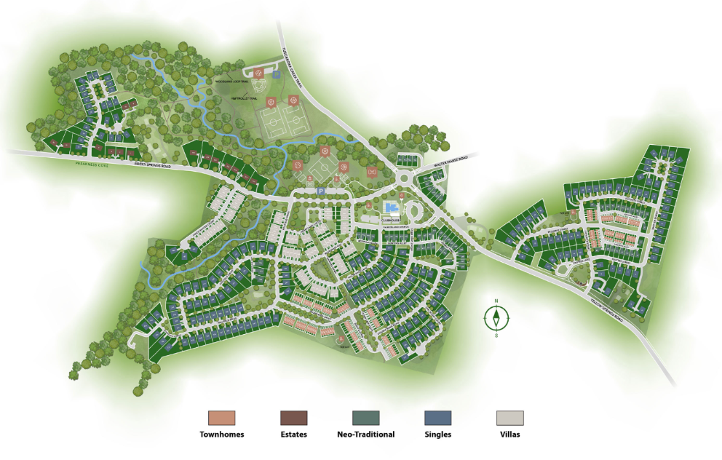

Per the site map above, Kellerton will feature the following counts of each residence type:

* Townhomes: 24
* Estates: 15
* Neo-Traditional: 65
* Singles: 208
* Villas: 75

Additionally, there are plans to develop Kellerton directly east of the subject property and across Yellow Springs Road. The following plat map shows the subject’s position relative to upcoming Kellerton Land Bays “D” and “E”:

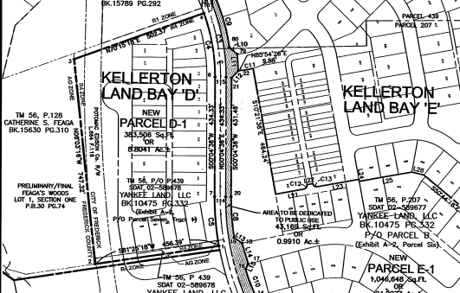

Subject

On the aerial view below, the subject property’s location relative to a constructed portion of Kellerton is noted.

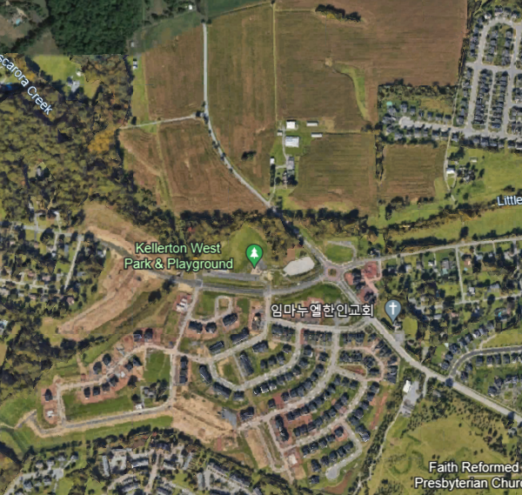

Kellerton

Subject

As mentioned previously, the site is located within U.S. Census Tract 23224-24-021-7507.02.

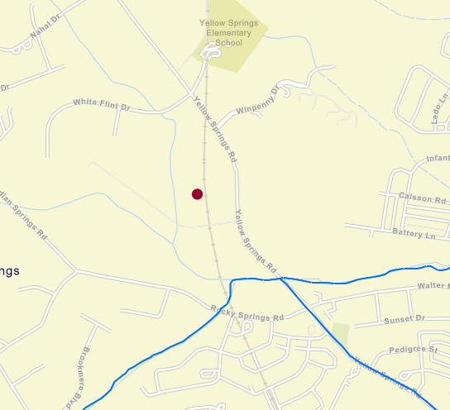

The following table summarizes 2023 estimates for this tract:

|  |  |
| --- | --- |
| **Census Tract: 7525.01 Summary** | |
| 2023 Estimated Median Family Income | $151,400 |
| Tract Population | 4,752 |
| Number of Households | 1,760 |
| 1-4 Family Units | 1,504 |
| Owner-occupied units | 1,270 |

# REAL ESTATE TAX ANALYSIS

The subject property is located within Frederick County, Maryland. Article 15 of the Declaration of Rights of Maryland’s Constitution requires that all real property is assessed and taxed uniformly. State law specifically requires that all taxable property shall be assessed based on its fair market value. The Maryland Department of Assessments and Taxation is responsible for appraising all real property and business personal property within the entire State of Maryland. Properties are appraised once every three years and property owners are notified of any change in their assessed value. Assessments are certified by the Department to local governments where they are converted into property tax bill by applying the appropriate property tax rates. Property tax rates vary widely. No restrictions or limitations on property taxes are imposed by the State, enabling cities and counties to set tax rates at the level required to fund governmental services. These rates can increase, decrease, or remain the same from year to year. If the proposed tax rate increases the total property tax revenues, the governing body must advertise that fact and hold a public hearing on the new tax rate. This is called the Constant Tax Yield Rate process.

The overall tax rate is a combination of State, county, and in some cases municipal tax rates. Property taxes are expressed as a dollar amount per $100 of assessed value. The following chart reflects the assessed value for both lots effective 7/1/2023:

**Tax Account: 21-428426**

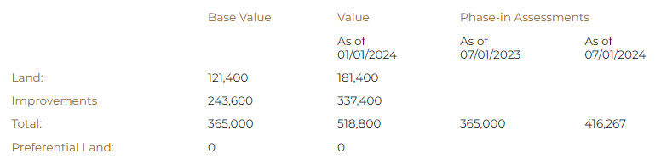

The property is subject to taxes levied by the State of Maryland and Frederick County. The following identifies the tax charges for the subject property:

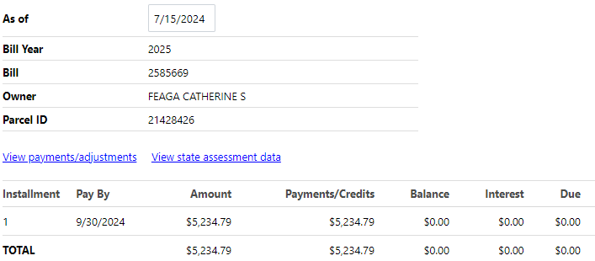

# MARKET ANALYSIS

The value of real estate is affected by the convergence of the ongoing changes in social, economic, governmental, and physical forces – which typically occur in a cyclical pattern. Real estate markets are dynamic and the typical life cycle includes the following stages:

* Growth—a period during which the market area gains public favor and acceptance
* Stability—a period of equilibrium without marked gains or losses
* Decline—a period of diminishing demand
* Revitalization—a period of renewal, redevelopment, modernization, and increasing demand

To determine the influence of economic forces on value, market participants analyze the relationships between current and anticipated supply and demand and the economic ability of the prospective purchasers. However, real estate markets differ significantly from the markets for other goods and services and have never been considered truly efficient markets. Real estate products are heterogeneous and changes in supply lag behind changes in demand for a specific real estate product because of the time needed to bring a new building to market. In a more efficient market, like a stock exchange, supply quickly reacts to changes in demand.[5]

The coronavirus pandemic disrupted typical economic activity (growth) locally, nationally, and throughout much of the developed world. It had a transformative impact on several real estate market segments – particularly retail, office, and restaurants; but at the same time increasing demand for other property types – particularly industrial, warehouse/flex, and suburban residential.

**Federal Open Market Committee**

The Federal Open Market Committee (FOMC) is probably the most extensively used and most potent of the Federal Reserve’s credit-regulating devices. The FOMC buys and sells US government securities in the open market, thereby exerting a powerful influence on the supply of money and the interest rate. The FOMC consists of twelve members—the seven members of the Board of Governors of the Federal Reserve System; the president of the Federal Reserve Bank of New York; and four of the remaining eleven Reserve Bank presidents, who serve one-year terms on a rotating basis. The rotating seats are filled from the following four groups of Banks, one Bank president from each group: Boston, Philadelphia, and Richmond; Cleveland and Chicago; Atlanta, St. Louis, and Dallas; and Minneapolis, Kansas City, and San Francisco. Nonvoting Reserve Bank presidents attend the meetings of the Committee, participate in the discussions, and contribute to the Committee’s assessment of the economy and policy options. In fact, through its daily operations, the FOMC maintains short-term money rates at selected target levels. In periods of economic crisis, the Fed supplies financial markets with necessary liquidity.

On September 20, 2023, the Federal Open Market Committee released a statement summarizing the key economic indicators of the United States: “Recent indicators suggest that economic activity has been expanding at a solid pace. Job gains have slowed in recent months but remain strong, and the unemployment rate has remained low. Inflation remains elevated.

The U.S. banking system is sound and resilient. Tighter credit conditions for households and businesses are likely to weigh on economic activity, hiring, and inflation. The extent of these effects remains uncertain. The Committee remains highly attentive to inflation risks.

The Committee seeks to achieve maximum employment and inflation at the rate of 2 percent over the longer run. In support of these goals, the Committee decided to maintain the target range for the federal funds rate at 5-1/4 to 5-1/2 percent. The Committee will continue to assess additional information and its implications for monetary policy. In determining the extent of additional policy firming that may be appropriate to return inflation to 2 percent over time, the Committee will take into account the cumulative tightening of monetary policy, the lags with which monetary policy affects economic activity and inflation, and economic and financial developments. In addition, the Committee will continue reducing its holdings of Treasury securities and agency debt and agency mortgage-backed securities, as described in its previously announced plans. The Committee is strongly committed to returning inflation to its 2 percent objective.

In assessing the appropriate stance of monetary policy, the Committee will continue to monitor the implications of incoming information for the economic outlook. The Committee would be prepared to adjust the stance of monetary policy as appropriate if risks emerge that could impede the attainment of the Committee's goals. The Committee's assessments will take into account a wide range of information, including readings on labor market conditions, inflation pressures and inflation expectations, and financial and international developments.[6]”

**National Employment Data**

According to the U.S. Department of Labor (July 5, 2024), total nonfarm payroll employment increased by 206,000 in June, and the unemployment rate changed little at 4.1 percent, the U.S. Bureau of Labor Statistics reported today. Job gains occurred in government, health care, social assistance, and construction.

This news release presents statistics from two monthly surveys. The household survey measures labor force status, including unemployment, by demographic characteristics. The establishment survey measures nonfarm employment, hours, and earnings by industry. For more information about the concepts and statistical methodology used in these two surveys, see the Technical Note.

**Survey Data**

Total nonfarm payroll employment increased by 206,000 in June, similar to the average monthly

gain of 220,000 over the prior 12 months. In June, job gains occurred in government, health

care, social assistance, and construction.

Government employment rose by 70,000 in June, higher than the average monthly gain of 49,000 over the prior 12 months. Over the month, employment increased in local government, excluding education (+34,000) and in state government (+26,000).

Health care added 49,000 jobs in June, lower than the average monthly gain of 64,000 over the

prior 12 months. In June, employment rose in ambulatory health care services (+22,000) and

hospitals (+22,000).

Employment in social assistance increased by 34,000 in June, primarily in individual and

family services (+26,000). Over the prior 12 months, social assistance had added an average of

22,000 jobs per month.

Construction added 27,000 jobs in June, higher than the average monthly gain of 20,000 over

the prior 12 months.

Retail trade employment changed little in June (-9,000), after trending up earlier in the

year. Furniture, home furnishings, electronics, and appliance retailers lost 6,000 jobs over

the month, while warehouse clubs, supercenters, and other general merchandise retailers gained

5,000 jobs.

Employment in professional and business services changed little in June (-17,000) and has

shown little change over the year. Temporary help services employment declined by 49,000 over

the month and is down by 515,000 since reaching a peak in March 2022. Employment in

professional, scientific, and technical services continued to trend up in June (+24,000).

Employment showed little change over the month in other major industries, including mining,

quarrying, and oil and gas extraction; manufacturing; wholesale trade; transportation and

warehousing; information; financial activities; leisure and hospitality; and other services.

In June, average hourly earnings for all employees on private nonfarm payrolls increased by

10 cents, or 0.3 percent, to $35.00. Over the past 12 months, average hourly earnings have

increased by 3.9 percent. In June, average hourly earnings of private-sector production and

nonsupervisory employees increased by 10 cents, or 0.3 percent, to $30.05.

In June, the average workweek for all employees on private nonfarm payrolls was 34.3 hours

for the third consecutive month. In manufacturing, the average workweek was unchanged at 40.2

hours, and overtime remained at 3.0 hours. The average workweek for production and

nonsupervisory employees on private nonfarm payrolls edged down by 0.1 hour to 33.7 hours.

**National Gross Domestic Product**

Real gross domestic product (GDP) increased at an annual rate of 1.4 percent in the first quarter of 2024, after increasing 3.4 percent in the fourth quarter of 2023.  Please note the following chart from the U.S. Bureau of Economic Analysis:

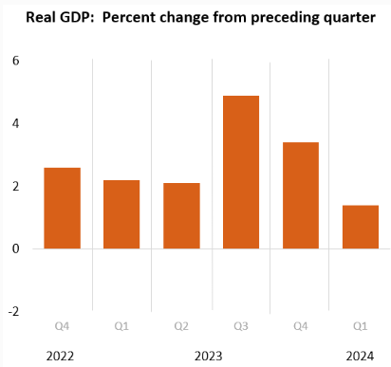

**Maryland Summary**[7][1]

Maryland payroll employment increased by 6,400 jobs (0.2 percent), on net, in May. Professional and business services (2,000 jobs) experienced the largest month-over-month increase in jobs, followed by government (1,200 jobs), and education and health services (1,200 jobs). Only trade, transportation, and utilities (100 jobs) experienced job losses in May.

On a year-over-year basis, Maryland payroll employment increased by 6,800 jobs (0.2 percent), on net. The most jobs were added over the year in government (13,900 jobs), followed by education and health services (13,100 jobs). The most jobs lost over the year were in trade, transportation, and utilities (8,900 jobs), construction (5,000 jobs), and professional and business services (4,400 jobs).

The unemployment rate in Maryland has risen 0.1 percentage point from April to 2.7 percent and has risen 0.8 percentage point from its May 2023 reading of 1.9 percent. Maryland's unemployment rate ties with Virginia's for the lowest in the Fifth District and the sixth lowest among U.S. states (after North Dakota, South Dakota, Vermont, Nebraska, and New Hampshire).

Residential housing permits decreased 26.6 percent in Maryland from April to May and were down -7.4 percent on a year-over-year basis.

According to the Federal Housing Finance Agency, home values in Maryland appreciated 5.2 percent from the fourth quarter of 2022 to the fourth quarter of 2023.

# ZONING

The subject property is zoned Agricultural (A) by the Frederick County Planning Department. The purpose of the Agricultural District (A) is to preserve productive agricultural land and the character and quality of the rural environment and to prevent urbanization where roads and other public facilities are scaled to meet only rural needs. The following is a snapshot from a zoning map provided by the Frederick County Zoning department with the subject parcel identified using a red arrow:



Agricultural (A) zoning regulations are presented on the following page.

|  |  |  |  |  |  |  |  |
| --- | --- | --- | --- | --- | --- | --- | --- |
| ***Use Classification*** | ***Minimum Lot Area*** | ***Minimum Lot Area per Unit*** | ***Lot Width*** | ***Front Yard*** | ***Side Yard*** | ***Rear Yard*** | ***Height*** |
| ***Agricultural District A*** | | | | | | | |
| Natural resources | 5 acres | - | 300 | 40 | 50 | 50 | 30' |
| Residential | See § 1-19-7.300 Below | | 100 | 40 | 10 | 30 | 30’ |
| Single family | See § 1-19-7.300 Below | | 100 | 40 | 10 | 30 | 30’ |
| Mobile Homes | See § 1-19-7.300 Below | | 150 | 40 | 15 | 30 | 30’ |
| Two Family Dwelling | 2 acres | 1 acre | - | - | - | - | - |
| Animal care and services | 5 acres | - | 300 | 40 | 50 | 50 | 30' |
| Open space uses | 5 acres | - | 300 | 40 | 50 | 50 | 30' |
| Tent campground | 10 acres | - | 300 | 40 | 50 | 50 | 30' |
| Institutional | 40,000 | - | 200 | 40 | 50 | 50 | 30' |
| Governmental and public utility | 40,000 | - | 200 | 40 | 50 | 50 | 30' |
| Nongovernmental utility | 40,000 | - | 200 | 50 | 50 | 50 | 30' |
| Commercial amusements | 5 acres | - | 200 | 40 | 50 | 50 | 30' |
|  |  |  |  |  |  |  |  |

Below is section § 1-19-7.300 of the Frederick County, Maryland Code of Ordinances which details the regulations for the Agricultural (A) zoning district:

1. In the Agricultural Zoning District, the preferred use is agriculture. The operation at any time of any machinery used in farming procedures and all other agricultural operations shall be permitted and have preference over all other uses.
2. The minimum lot size for single-family dwellings will be 40,000 square feet and, except as provided in § 1-19-7.300(C), subdivision will be permitted only as follows: a minor subdivision of 3 lots will be permitted to be subdivided off an original tract of land; thereafter land will have to be rezoned before additional dwellings, other than tenant houses, may be built. An original tract of land shall be as described in the county land records as of August 18, 1976.
3. Clustering
   1. *Purpose and intent.*
      1. To encourage the conservation of farmland in the Agricultural Zoning District by planning the residential development allowed in the zone to provide for the best obtainable siting, access and location of lots on a tract.
      2. To provide for a well-planned development while minimizing the use of prime agricultural land.
   2. *Requirements.*
      1. For the purpose of this subsection "clustering" shall be defined as directing the subdivision of lots on a single tract of land to meet the purposes of this section or transferring the authorized subdivision lots from adjacent tracts onto one tract for development. The Planning Commission shall make the final determination as to whether the cluster development can be achieved in keeping with the purposes of this section.
      2. When transferring authorized subdivision lots from 1 or more tracts, the minimum original tract area required for transfer shall be 25 acres. However, adjoining tracts of less than 25 acres under the same ownership may receive the rights if the Planning Commission determines that this will preserve prime farmland.
      3. Minimum lot size, width and yard areas shall be as specified in the Agricultural District. Lot sizes which are part of the cluster should be kept to a minimum in order to limit the impact on the future agricultural use of the remainder. Lot size shall average not more than 1.5 acres in size with no lots exceeding 2 acres. The Planning Commission shall have the authority to grant modifications to lot sizes based on percolation and other Health Department requirements.
      4. Subdivision under this subsection shall be as follows. A minor subdivision of 3 lots will be permitted to be subdivided on an original tract of land 25 acres or less. An original tract shall be as defined in § 1-19-7.300(B). On an original tract of land containing more than 25 acres, the Planning Commission may allow 1 lot in addition to those allowed on lesser tracts for each additional 50 acres or part thereof above the first 25 acres subject to the requirements of this section. The Planning Commission may preclude clustering rights where subdivision under this section will not conserve farmland, such as where the tract is primarily in wooded areas, floodplains, wetlands, steep slopes and other areas not in pasture or crop use.
      5. All clusters of 6 or more lots shall be served by an internal public street and shall not be stripped along an existing roadway.
   3. *Procedures.*
      1. *Concept plan.* For the subdivision of tracts eligible for cluster lots, a concept plan shall be submitted to the staff a minimum of 60 days prior to the meeting at which it is to be considered by the Planning Commission showing all standard and potential cluster rights to determine the feasibility of subdivision rights for the original tract(s) of land. The plan shall be prepared in accordance with a "sample" cluster plan and show the following:
         1. The lot layout (scale no smaller than 1 inch equals 100 feet) including building restriction lines and appropriate dimensions;
         2. Street layout;
         3. Vicinity map (scale no smaller than 1 inch equals 2,000 feet) showing the tract(s) and total acreages included within the plan;
         4. Topography with minimum 10 foot contours (USGS Topo. Interpretation is permitted for Concept Plan);
         5. Development rights table indicating acreages and development rights, both standard and cluster, for each tract and the total;
         6. Soils data for the cluster area and the remaining farmland.
      2. The Planning Commission will have final approval over the location and layout of the proposed clustering of lots. The Planning Commission shall consider the following when reviewing Concept Plans.
         1. *Soils*. The cluster plan should minimize the use of the higher quality soils (class I, II and III as designated in the soils classification study) and maximize the use of steeper sloped areas, areas of poorer soils and areas which are otherwise less productive for agricultural uses.
         2. *Surrounding land use and zoning*. The cluster plan shall consider the existing land uses and zoning in the vicinity. Generally, new lots which are adjacent to existing development or residential zoning are preferred to creating an isolated cluster of new houses.
      3. Concept plan approval shall become null and void at the end of 1 year from the date of approval unless a combined preliminary/final plat or a preliminary plat has been submitted for approval for the property.
      4. If the concept plan is approved by the Planning Commission, the developer may then proceed with platting of the clustered development in accordance with the subdivision regulations and the approved concept plan. Final plats shall show all remaining parcels combined into 1 remainder except, however, any remaining parcel(s) separated by a public road shall be considered separate parcels and each parcel shall retain 1 development right. The plat shall bear a statement indicating that "The land lies within an approved agricultural cluster development and no further subdivision of the remaining land is permitted unless the property is placed in another zone or further subdivision is allowed by ordinance or regulation of Frederick County, Maryland."
   4. Even though a subdivision plat is not required for land subdivided for the purpose to be used as a farm, such subdivided land shall be counted as a lot and will be counted in the number of allowable lots that may be subdivided off the original tract of land.
   5. When filing a subdivision plat for less than the 3 lots allowed to be subdivided off the original tract of land, the remaining parcel must be designated "Remainder" on the subdivision plat or lose all further subdivision rights allowed under this section.

# SITE DATA

The subject property includes one lot totaling 6.29 acres or 273,992 square feet of land and is located northwest of downtown Frederick. The site is panhandle in shape with flat topography and has a driveway accessible from Yellow Springs Road which is a two-lane, asphalt improved roadway maintained by Frederick County. Please note the following recorded plat:

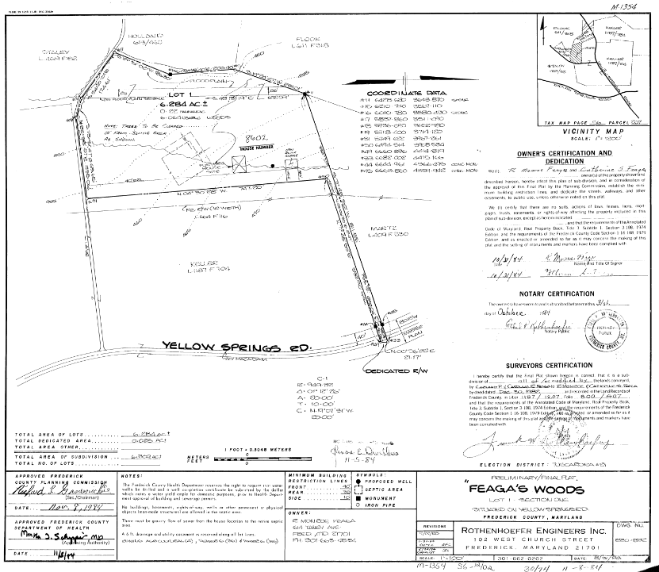

The site has an asphalt driveway, parking area and a detached garage with three vehicle spaces and doors that are operated manually. The site has a private well and septic.

The following are environmental factors observed during the property inspection:

1. Cleanliness/orderliness of the site.
   1. **Consistent with similar properties.**
2. Standpipes, vents, ground subsidence, or other indications of underground storage tanks.
   1. **None observed.**
3. Denuded or dead vegetation indicating spills or dumping.
   1. **None observed.**
4. Discoloration of soil indicating spills or dumping.
   1. **None observed.**
5. Standing water or leading pipes, valves, or containers indicating defective storage facilities.
   1. **None observed.**
6. Unusual smells or noxious odors inside or outside of any building.
   1. **None observed.**
7. Signs of explosions or chemical spills.
   1. **None observed.**
8. Storage barrels, drums, or containers filled with liquid chemicals.
   1. **None observed.**
9. Refuse piles, incinerators, dump areas or abandoned vehicles.
   1. **None observed.**
10. Wetlands, bogs, or lakes on or near the property.
    1. **None observed.**
11. Indications of asbestos to the best of your ability.
    1. **None observed.**
12. Mounds or depressions which might indicate buried substances.
    1. **None observed.**
13. Electrical equipment or transformers.
    1. **None observed.**
14. Unexplained vehicle tracks indicating unreported disposal activity.
    1. **None observed.**

The following site data summarizes the subject site:

|  |  |  |  |  |
| --- | --- | --- | --- | --- |
| **SITE ELEMENT** | **DATA** | **SITE ELEMENT** | | **DATA** |
| **Approach** | Yellow Springs Road. | **Waterfront** | | None. |
| **Access** | Yellow Springs Road. | **Nuisances(s)** | | None. |
| **Ingress** | **Hazards** | | None. |
| **Egress** | **Contamination** | | None. |
| **Surrounding Uses** | Residential, agricultural. | **Restrictive Covenants** | | None. |
| **Frontage** | Approximately 820 feet along Yellow Springs Rd. | **Common Elements** | | None. |
| **Visibility** | Good. | **Easements** | | None. |
| **Size** | 6.29 acres or 273,992 square feet. | **Encumbrances** | | None. |
| **Soils** | Typical | **Utilities/Services** | | Private well and septic |
| **Shape** | Irregular | **Clouds** | | None. |
| **Topography** | Flat. | **Anticipated Public or private improvements** | | None. |
| **Drainage** | Assumed adequate. | **Excess/Surplus Land** | | None. |
| **Flood Area** | Approximately 8% (0.51 acres), according to FEMA Map Zone X, 24021C0277E (effective 8/1/2023). | **Current Use of Site** | Residential. | |
| **Wetlands** | None. | **On-site Parking** | Asphalt parking area, detached garage with three vehicle spaces. | |
| **Entitlements** | Existing improvements. | | | |

**FEMA FLOOD MAP: 24021CO277E/ effective 8/1/2023**

It is important to note that the opinion of value provided in this report is based on the assumption that the property is not negatively affected by the existence of hazardous substances or other environmental conditions. Real Estate Appraisers are not experts in the identification of hazardous substances or other environmental conditions. During the property inspection and inquiries of the subject site, the appraisers did not become aware of any information that would lead to the conclusion that any negative environmental conditions exist on the subject property. The presence of contamination could negatively impact our opinion of value.

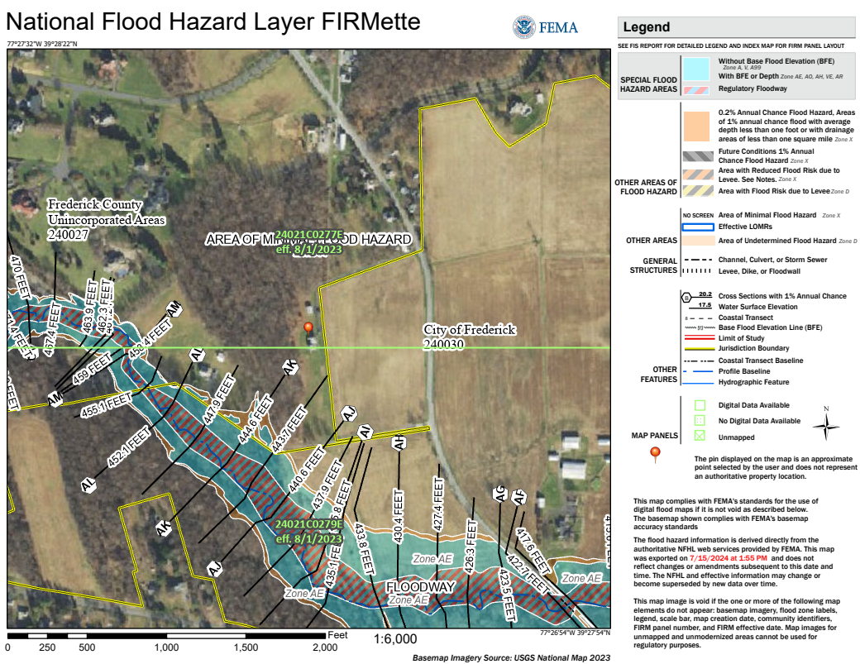

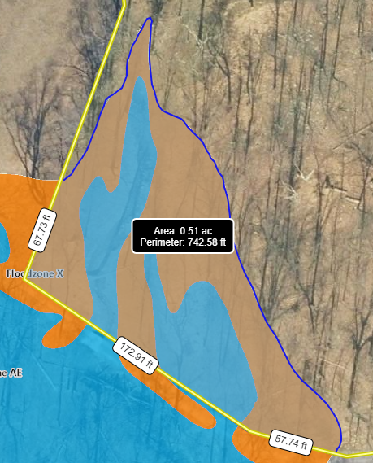

# DESCRIPTION OF IMPROVEMENTS

The subject property is improved with a single-unit residential dwelling, detached garage with three vehicle spaces, and driveway. The main improvement is a single-unit residence that has approximately 2,584 square feet of gross square feet above grade building area. The second is a detached garage containing approximately 864 square feet of gross building area. According to Frederick County land records, the residence was constructed in 1987 and the detached garage was constructed in 1983 according to the property owner.

|  |  |  |  |
| --- | --- | --- | --- |
| **BUILDING ELEMENT SUMMARY – SINGLE UNIT RESIDENTIAL** | | | |
| **Building Age/Year Built** | 37 years/1987 | **Overall Condition** | Average. |
| **Building Type** | Two-story residential house. | **Roof System** | Pitched, wood frame, asphalt shingle coverings. |
| **Building Height (overall)** | 25 - 30 feet (estimated). | **Building Structure** | Concrete block/wood frame. |
| **Foundation** | Concrete block. | **Ceiling Height** | 8 feet |
| **Number of levels** | Two above grade. | **Security** | Standard locks. |
| **Veneer** | Brick, vinyl. | **Doors** | Pedestrian, wood core. |
| **Windows** | Wood double hung. | **Drains/downspouts** | Aluminum. |
| **Electrical Service** | Assumed adequate. | **Plumbing** | Standard fixtures. |
| **Gross Building Area (SF)** | 2,584 | **Partition Walls** | Finished drywall. |
| **Flooring** | Combination of finished hardwood laminate tile and ceramic tile. | **Lighting** | Installed ceiling fixtures. |
| **Overall Construction Quality** | Good. | **Heating/AC** | HVAC. |
| **Effective Age** | 10 years | **Total Economic Life** | 50 Years |
| **Main Level** | The main level includes a lounge, kitchen, living room, one full bathroom, one half bathroom, and one bedroom. Flooring is a combination of finished hardwood, laminate tile, and ceramic tile. Walls and ceilings are finished drywall/plaster. Kitchen includes electric stove/oven appliance, installed microwave with vent, dishwasher, double aluminum sink. The cabinets are wood and the countertops are laminate. Bathroom fixtures are standard – full bath has bath/shower, toilet, sink with laminate countertops and wood cabinets. Powder room has toilet and sink. | | |
| **Upper Level** | The upper level contains one full bathroom, two bedrooms (one is currently used as an office). Flooring is a combination of finished hardwood and ceramic tile. Full bath fixtures are standard – bath/shower, toilet, sink with laminate countertop and wood cabinets. | | |
| **Lower Level** | Unfinished – includes laundry area, storage, water heater, and opens along the West façade. Flooring is concrete with exposed ceiling throughout. | | |

**Main Level Sketch:**

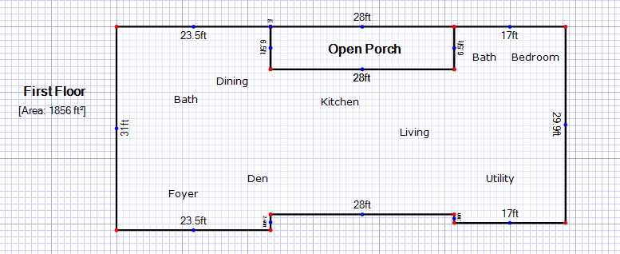

**Second Level Sketch:**

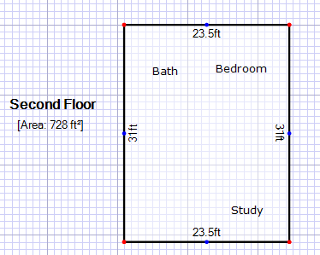

The site is also improved with a concrete block detached garage that has approximately 864 square feet of gross building area. This building has three overhead doors and one standard pedestrian doorway. The following page contains a building element summary for the detached garage.

|  |  |  |  |
| --- | --- | --- | --- |
| **BUILDING ELEMENT SUMMARY – DETACHED GARAGE** | | | |
| **Building Age/Year Built** | 41 years/1983 | **Overall Condition** | Average. |
| **Building Type** | One story garage. | **Roof System** | Pitched, wood frame, asphalt shingle coverings. |
| **Building Height (overall)** | 10 feet (estimated). | **Building Structure** | Concrete block/wood frame. |
| **Foundation** | Concrete slab. | **Ceiling Height** | 9 feet (estimated). |
| **Number of levels** | One. | **Security** | Standard locks. |
| **Veneer** | Cinderblock. | **Doors** | One pedestrian and three overhead garage doors. |
| **Windows** | None. | **Drains/downspouts** | None. |
| **Electrical Service** | Assumed adequate. | **Plumbing** | None. |
| **Gross Building Area (SF)** | 864 | **Partition Walls** | Finished drywall. |
| **Flooring** | Concrete | **Lighting** | Installed ceiling fixtures. |
| **Overall Construction Quality** | Average. | **Heating/AC** | None. |
| **Effective Age** | 15 years | **Total Economic Life** | 20 Years |
| **Comments** | Property owners currently use detached garage as storage area. Garage has three vehicle spaces with three overhead doors for each space and a side door for pedestrians. Each garage car door is operated manually. Ceiling is exposed throughout. | | |

To estimate the contributory value of the detached garage building, I used building estimates from Marshall and Swift, please see below:

|  |  |  |  |  |
| --- | --- | --- | --- | --- |
| **REPLACEMENT COST – DETACHED GARAGE** | | | | |
|  | | **VALUE** | **DETAIL** | |
| **Direct Cost** | | $44,092.84 | **Reproduction Rate Selection**  **Reference: Marshall and Swift Valuation Service**  **Section 12, Page 35/Class “C” – Low Cost (-) Quality**  Residential Garage - Detached Area 864 Square Feet, Gross  Base Rate/Sq. Ft. $45.75  Building Total $45.75  Refinements: Local Multiplier .99  Current Cost Multiplier .99  Cumulative Total .98  $45.75 x .98 = $47.56/GSFBA  Building 864 Sq. Ft. @$47.56 = $41,091.84  Plus estimated cost per overhead garage door (3) -- $3,000 | |
| **Indirect Cost/Ent. Profit** | | **$5,291.14** | Profit estimated at 10% of building costs; Indirect costs estimated at 2%. | |
| **Contingencies** | | **$4,409.28** | Estimated at 10% of building costs. | |
| **TOTAL COST** | | **$53,793.26** |  | |
| **DEPRECIATION** | | | | |
| **Curable Physical Deterioration** | | $0 | The subject property does not currently have any curable physical deterioration. | |
| **Incurable Physical Deterioration** | | $0 | The subject property does not currently have any incurable physical deterioration. | |
| **Building Depreciation** | | $26,896.63 | This was estimated based on the age/life method which account for the building effective age (10 years) and expected life (20 years), this results in a 50% depreciation. | |
| **Total Depreciation** | **$**26,896.63 | | |  |
| **Contributory Value** | **$26,896.63** | | | **Rounded to $27,000** |

The total contributory value for the attached garage is $27,000. This will be added to the site valuation.

# PHOTOGRAPHS OF THE SUBJECT PROPERTY

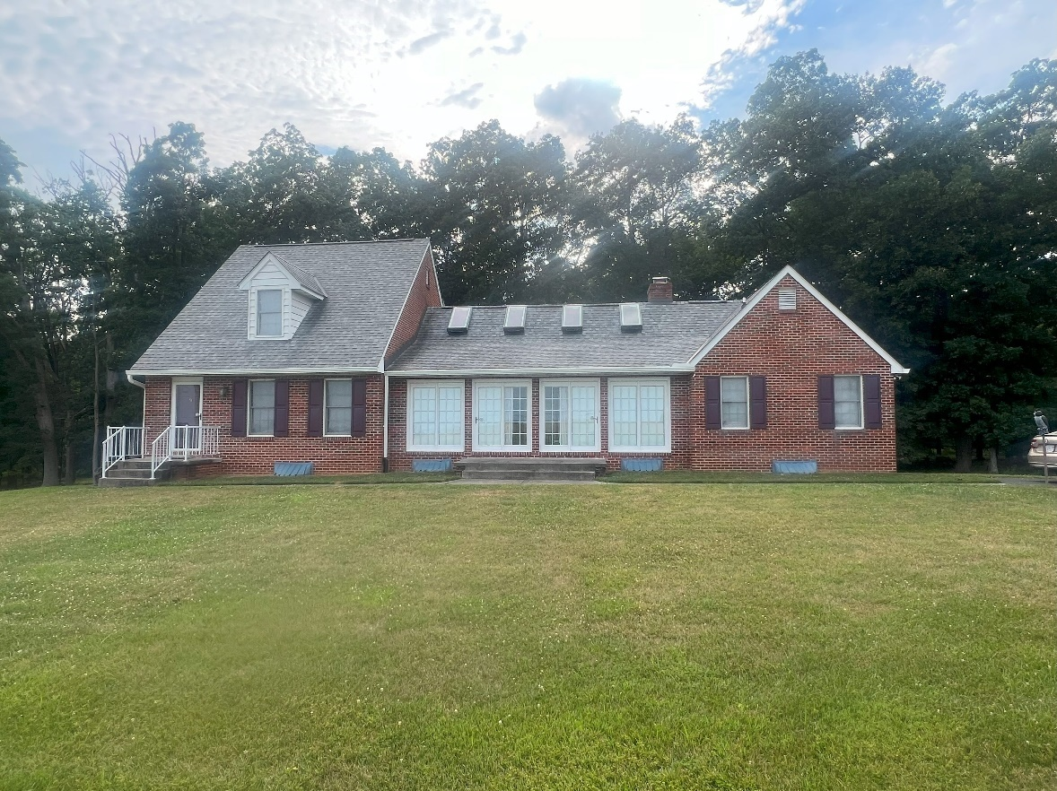

**RESIDENCE – EAST (FRONT) FAÇADE**

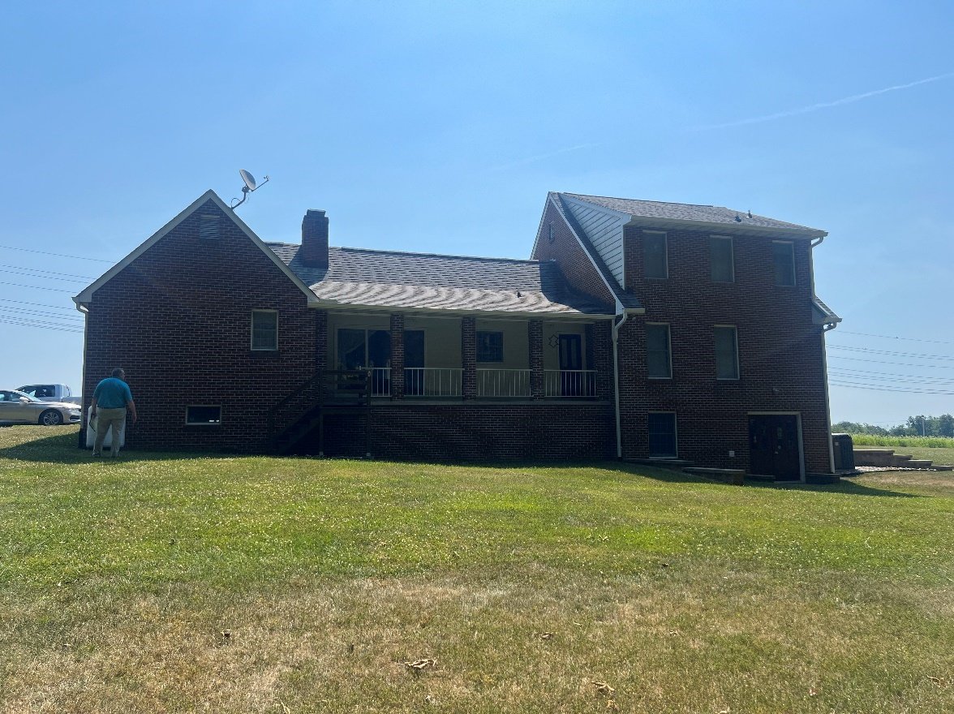

**RESIDENCE – WEST (REAR) FAÇADE**

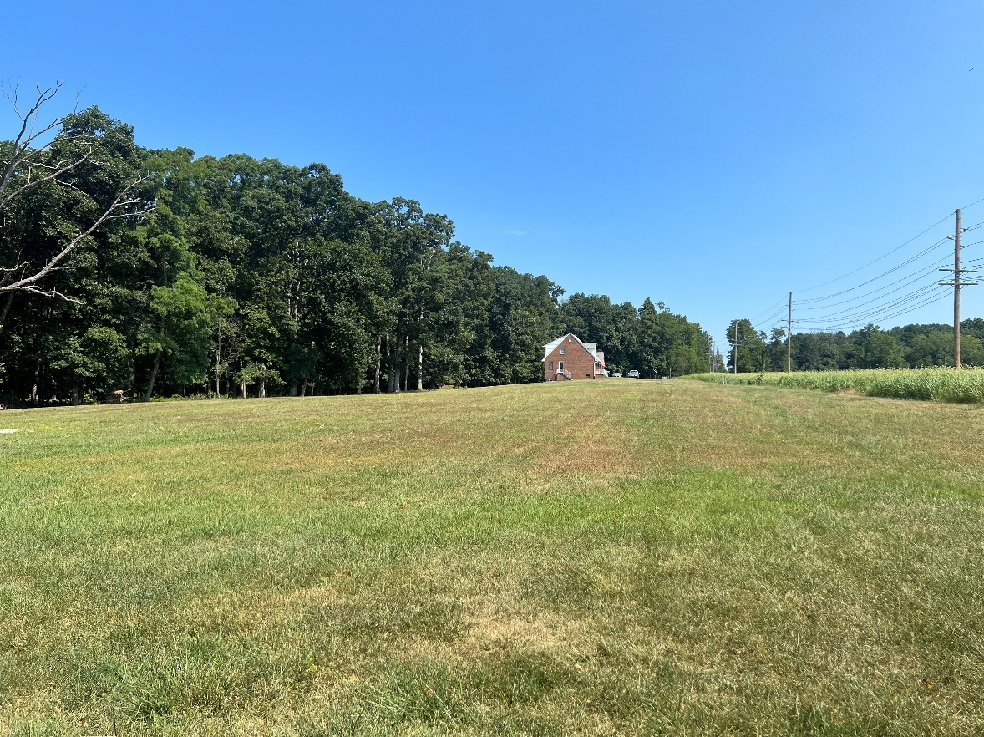

**SIDE YARD AND (EAST) FAÇADE**

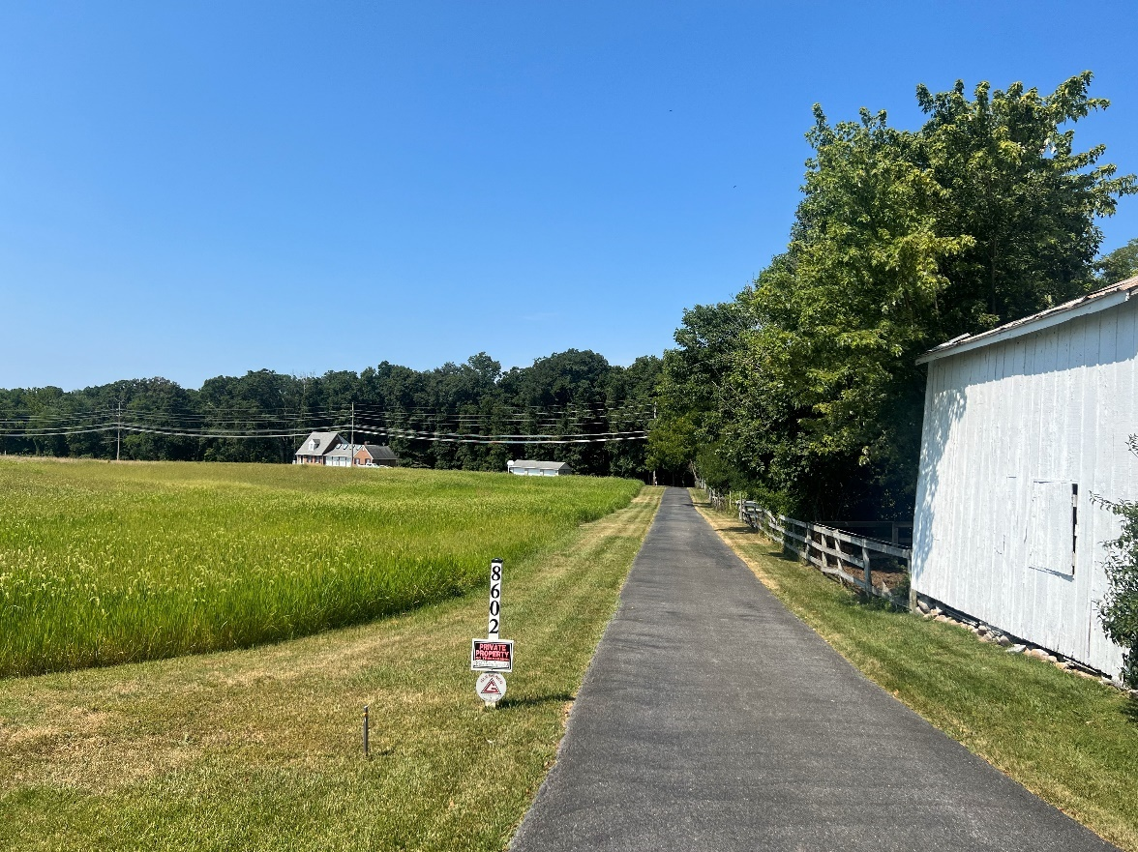

**PROPERTY VIEW FROM DRIVEWAY**

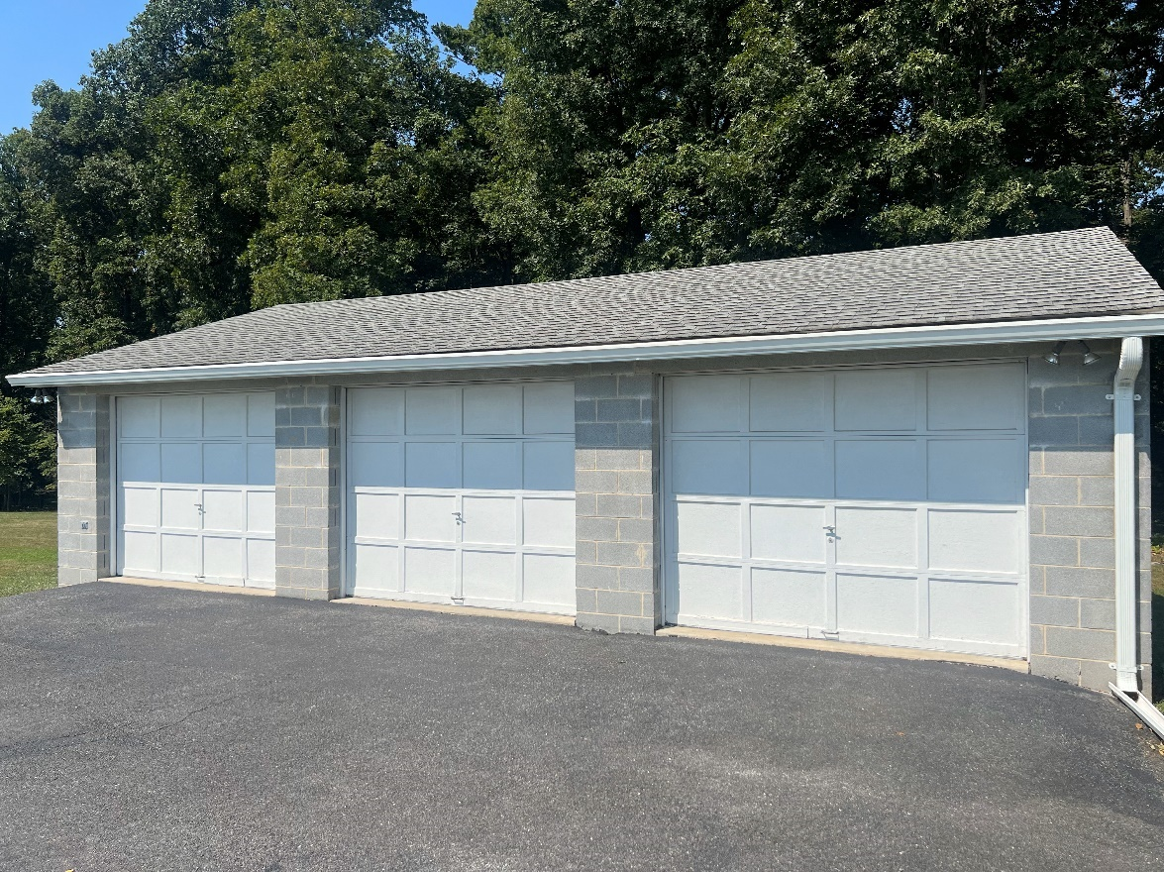

**DETACHED GARAGE**

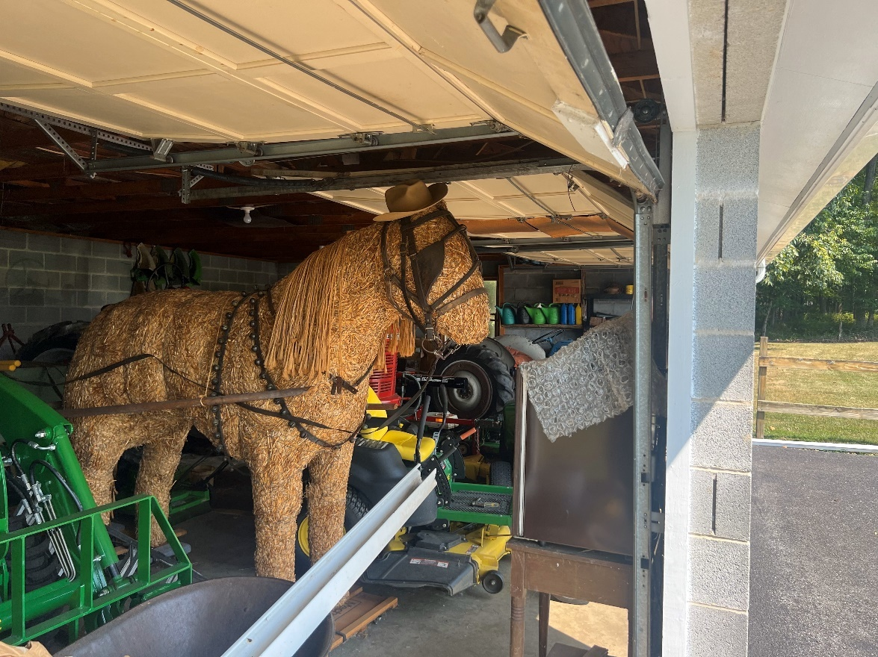

**DETACHED GARAGE INTERIOR**

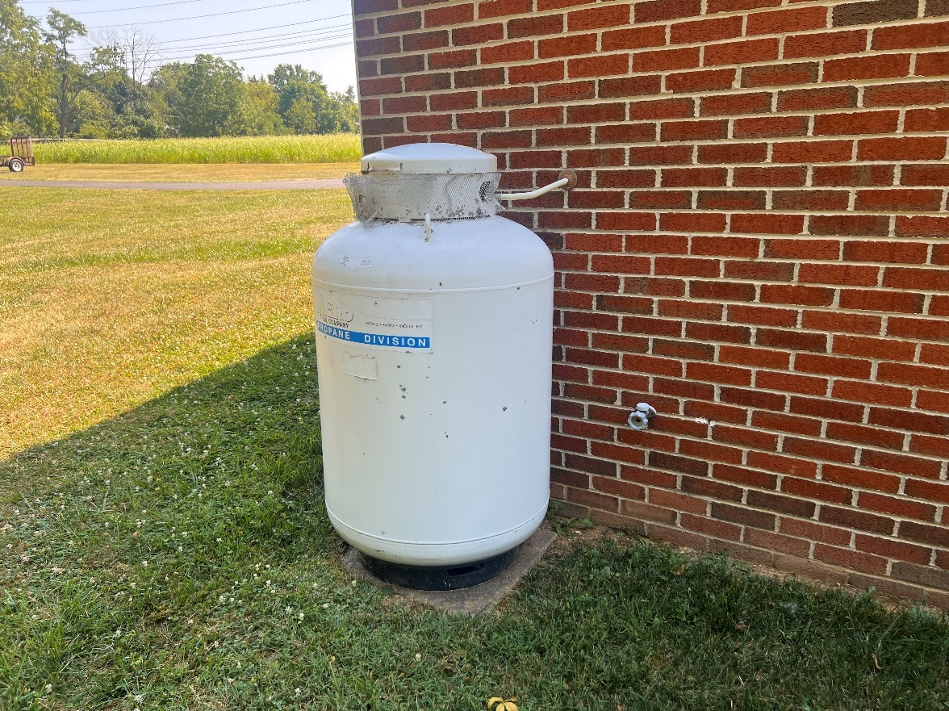

**PROPANE TANK**

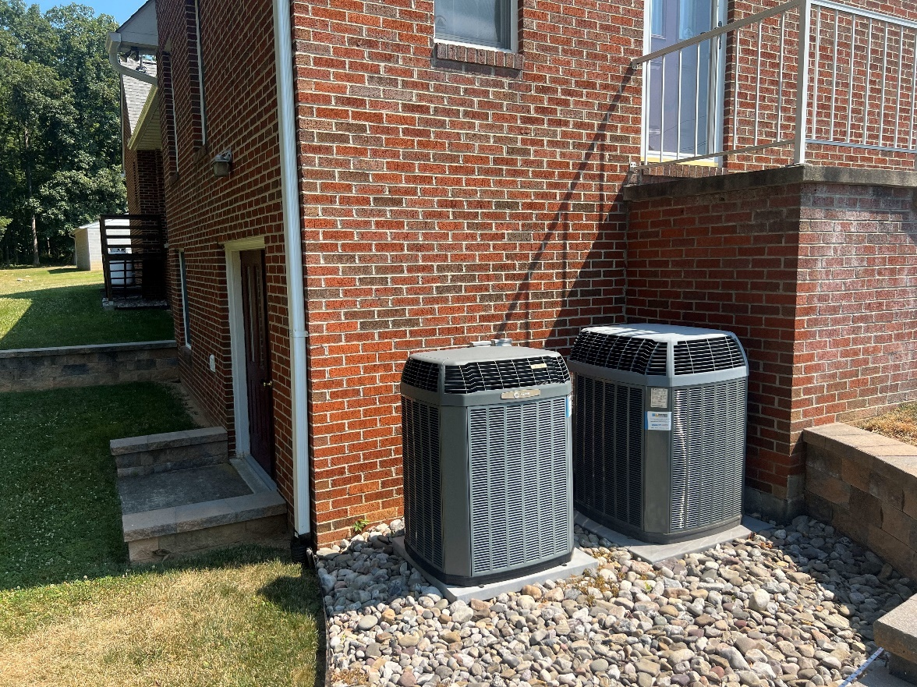

**HVAC SYSTEM**

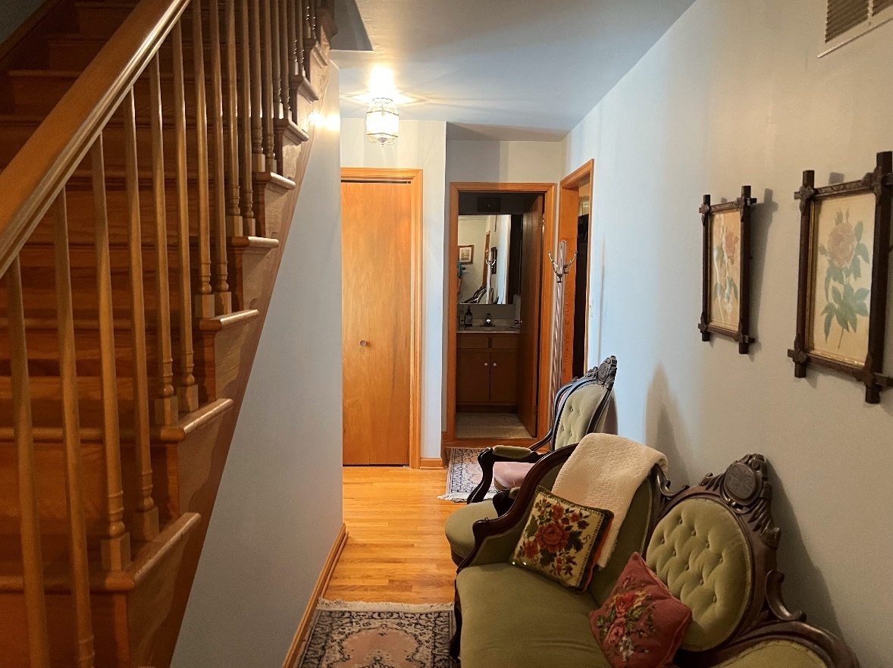

**FRONT FOYER**

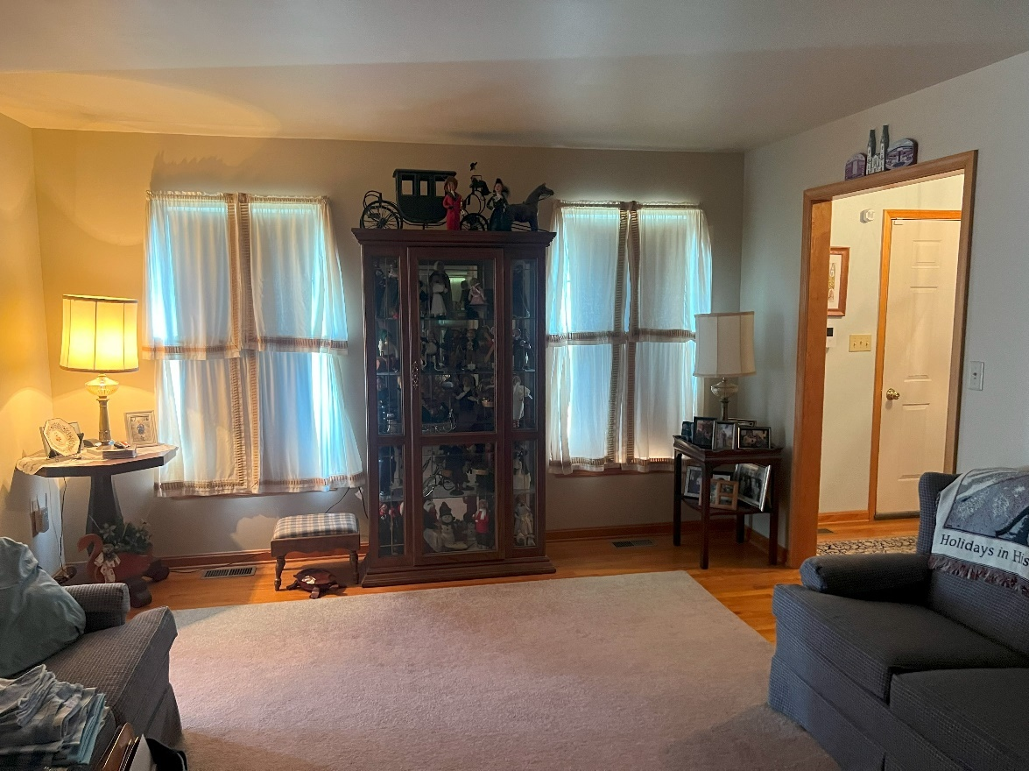

**LIVING ROOM**

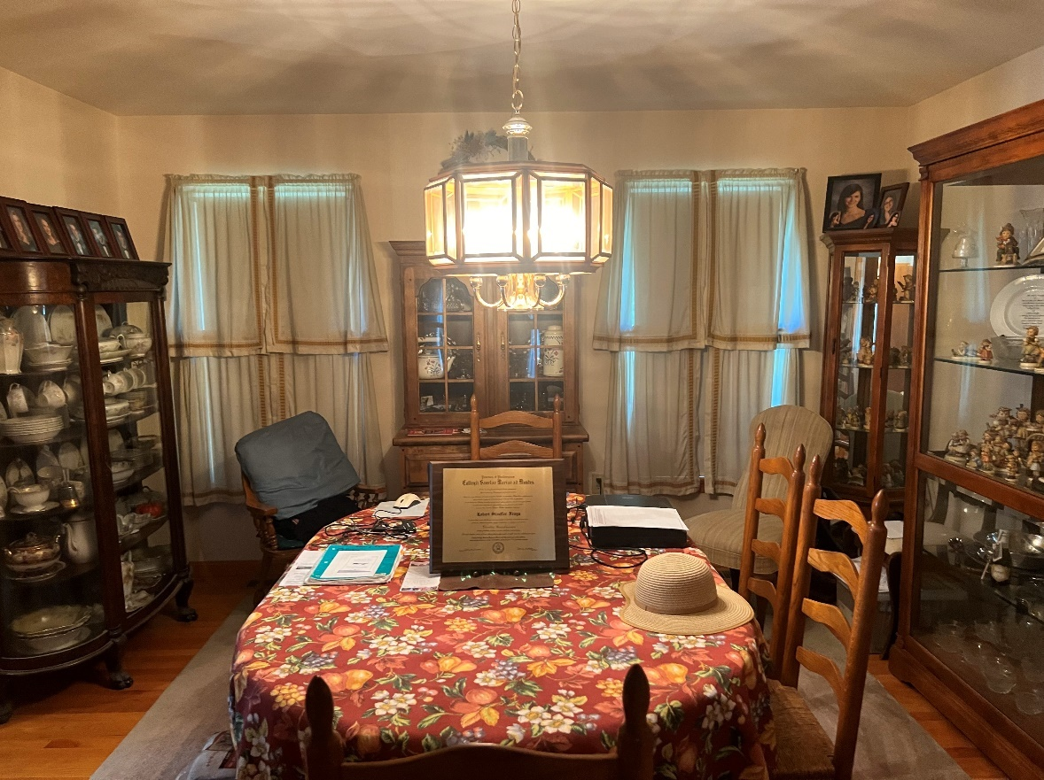

**DINING ROOM**

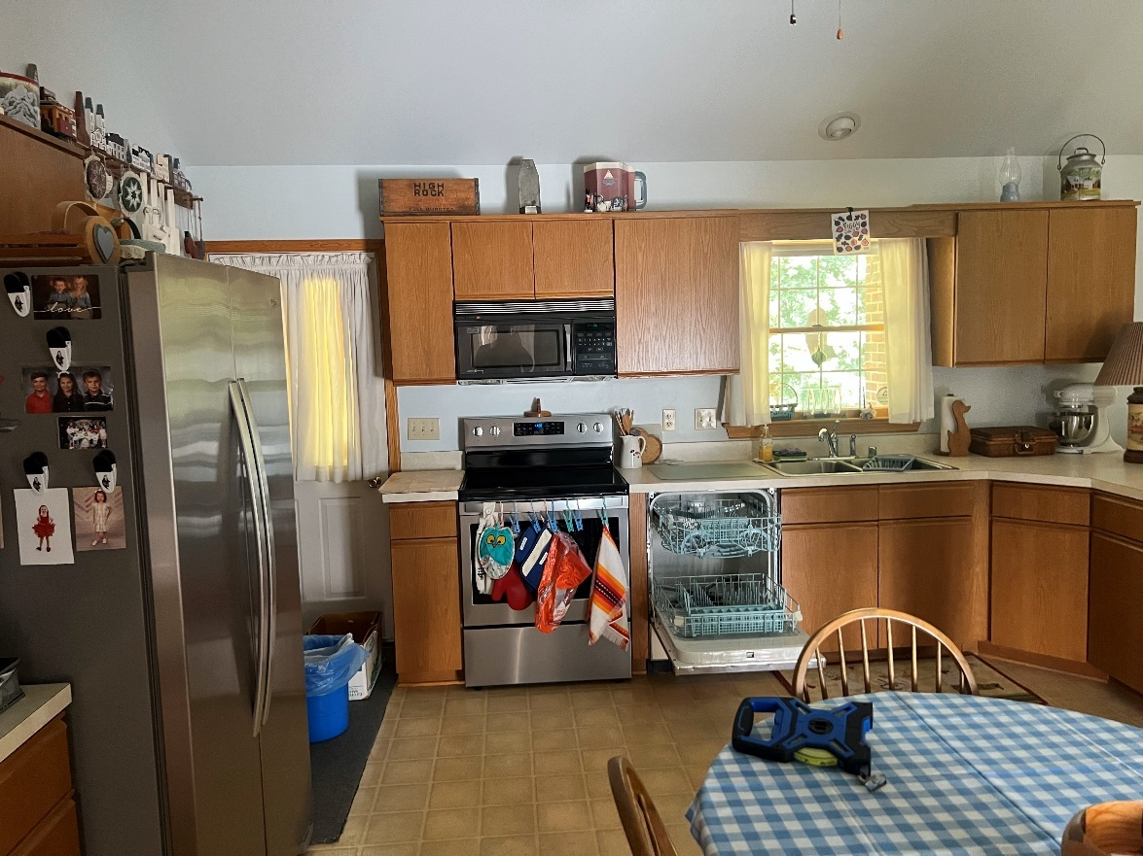

**KITCHEN**

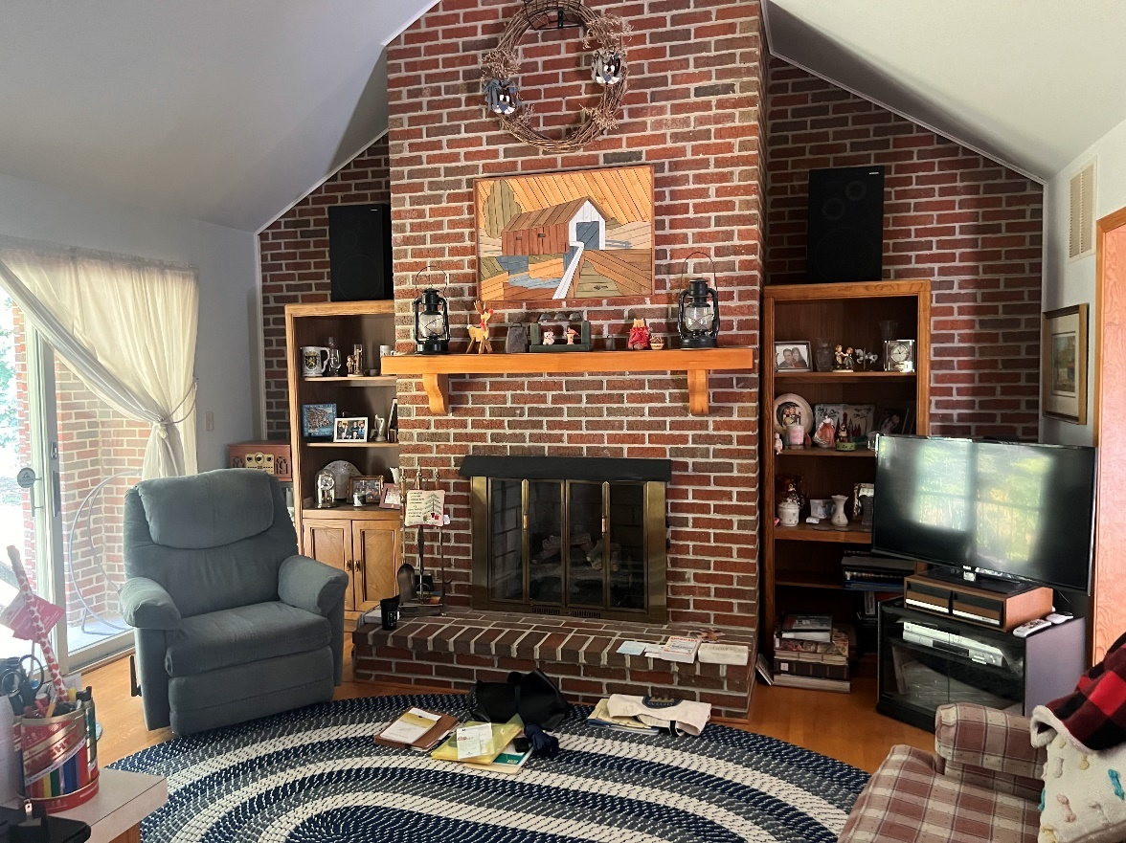

**FAMILY ROOM**

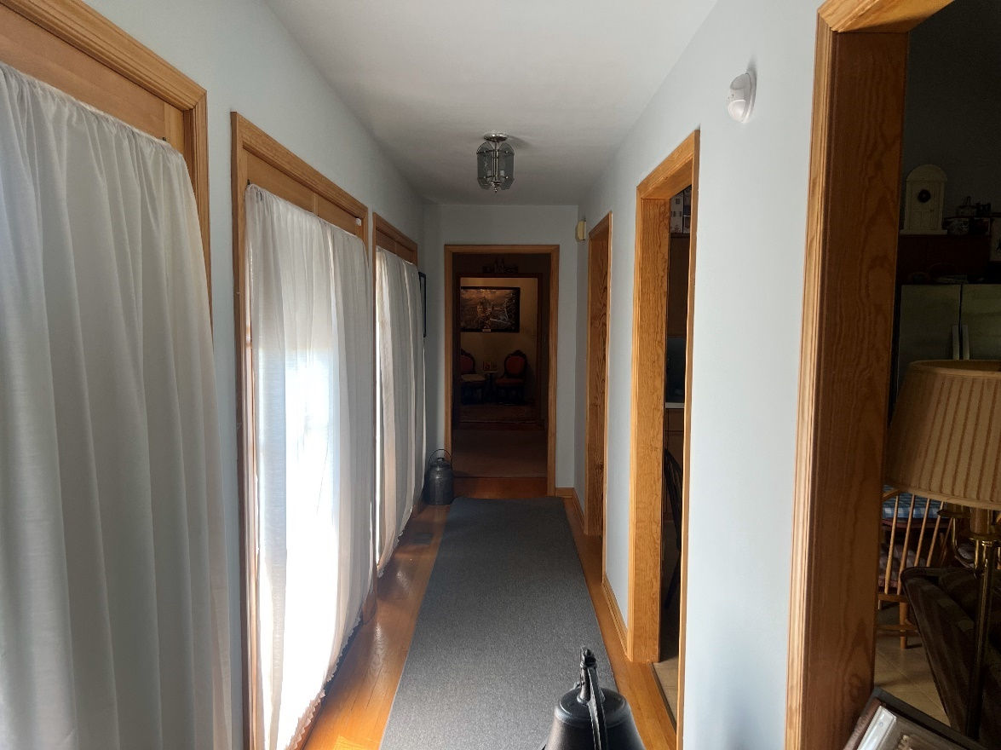

**HALLWAY**

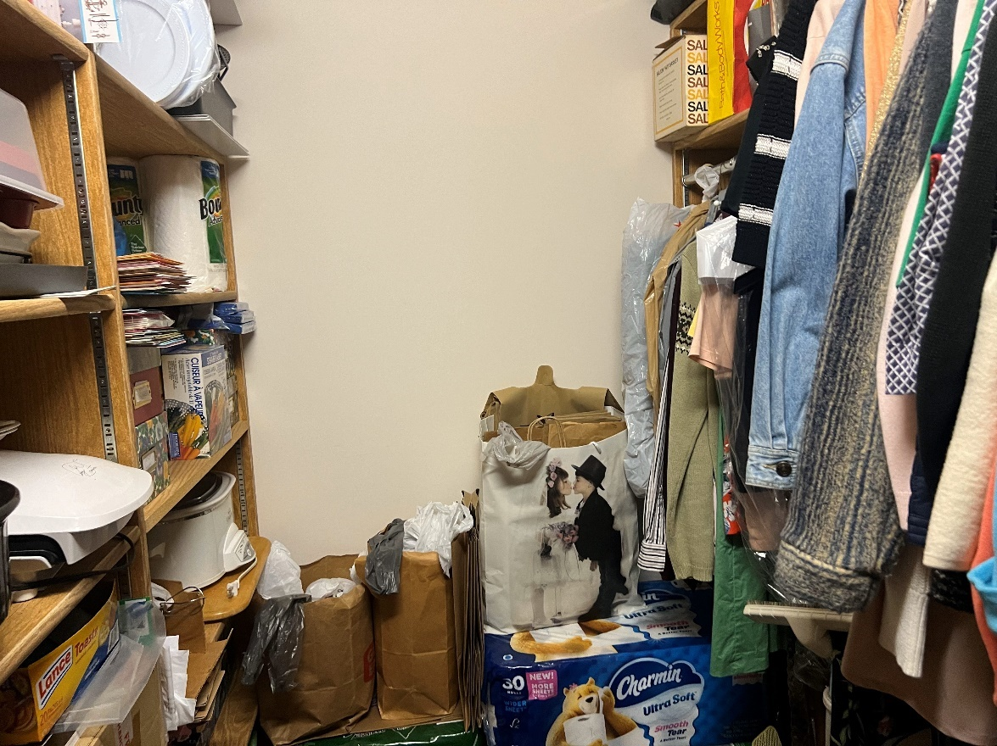

**STORAGE ROOM**

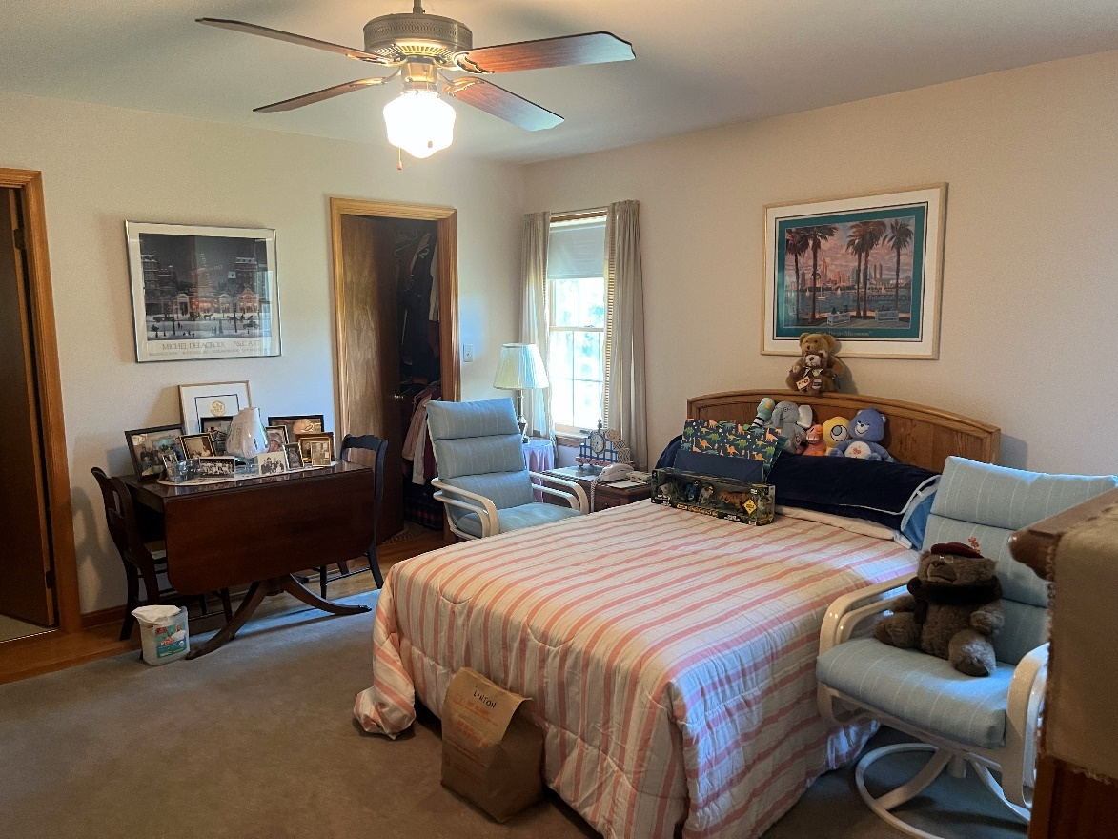

**BEDROOM #1**

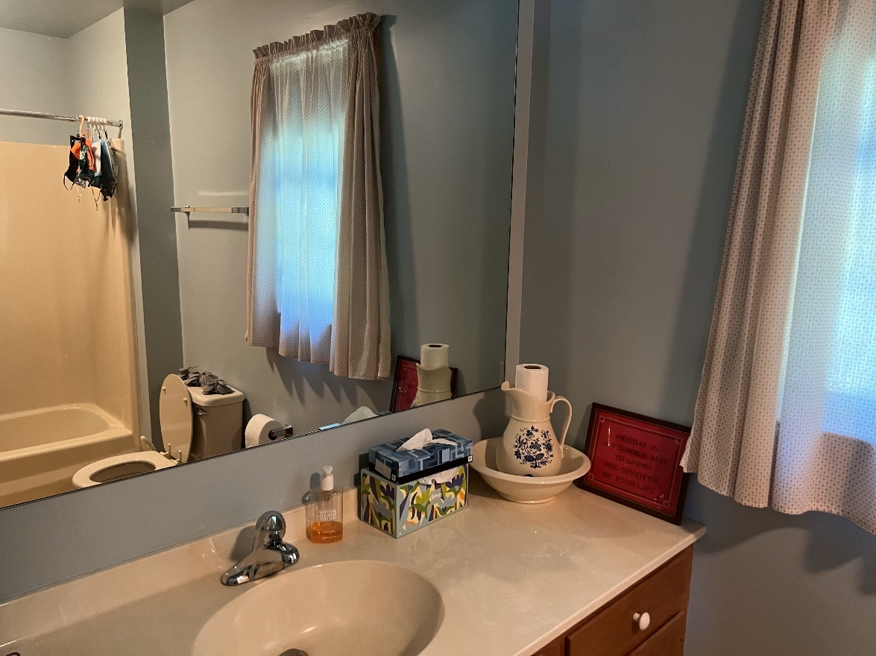

**FIRST LEVEL BATHROOM**



**BEDROOM CLOSET**

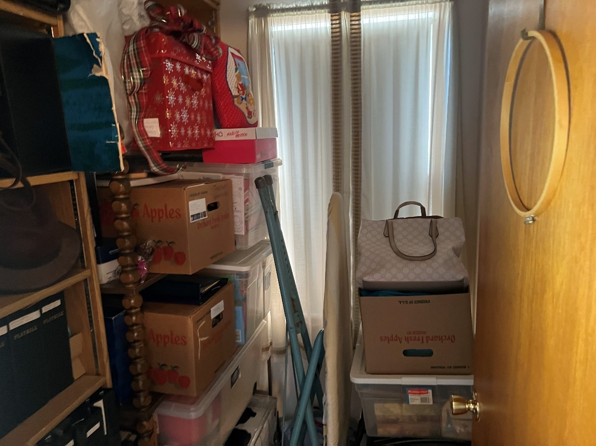

**UTILITY ROOM**

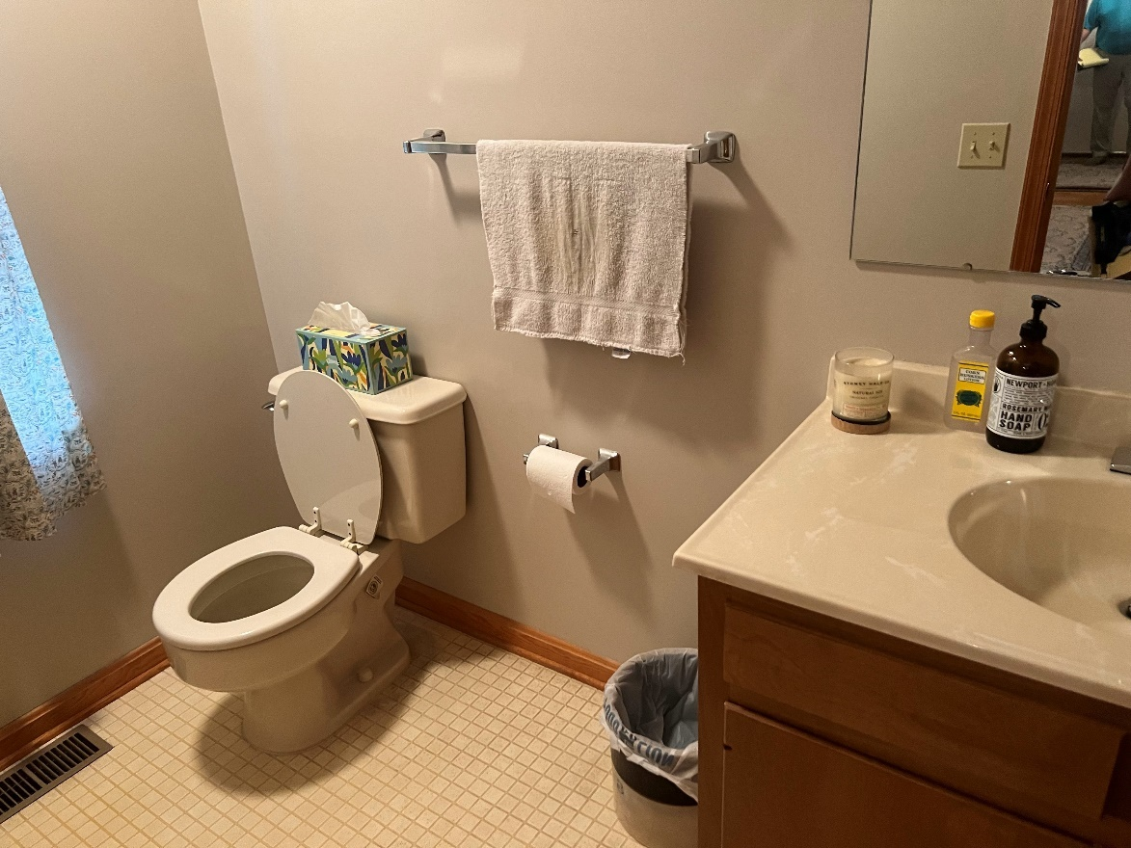

**POWDER ROOM**

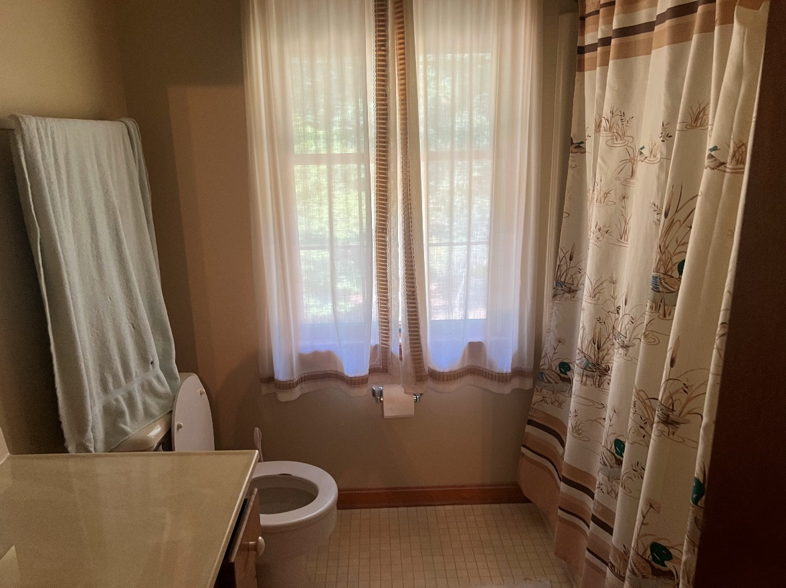

**SECOND LEVEL BATHROOM**

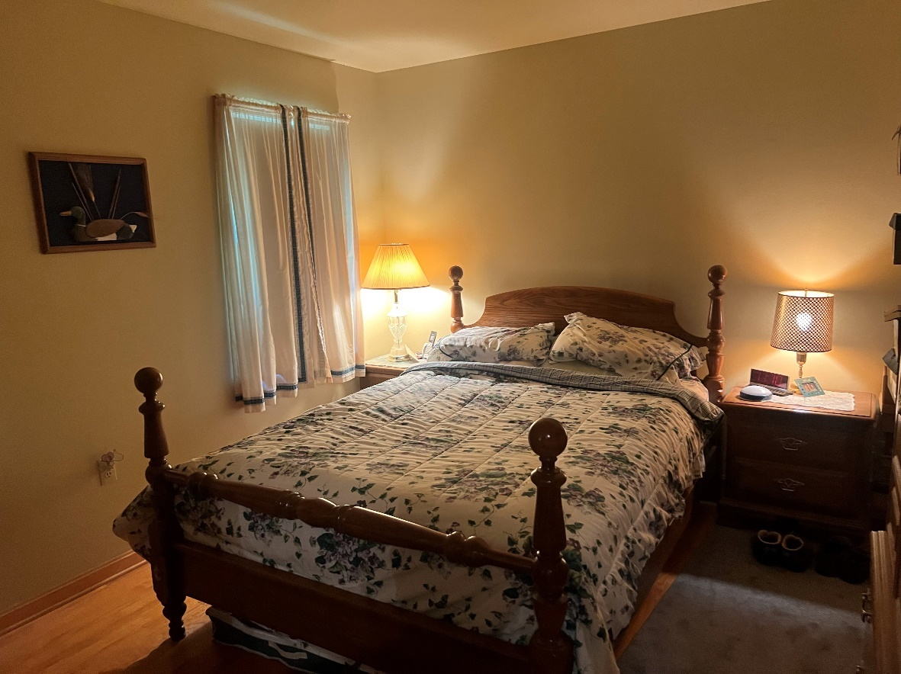

**SECOND LEVEL BEDROOM 1**

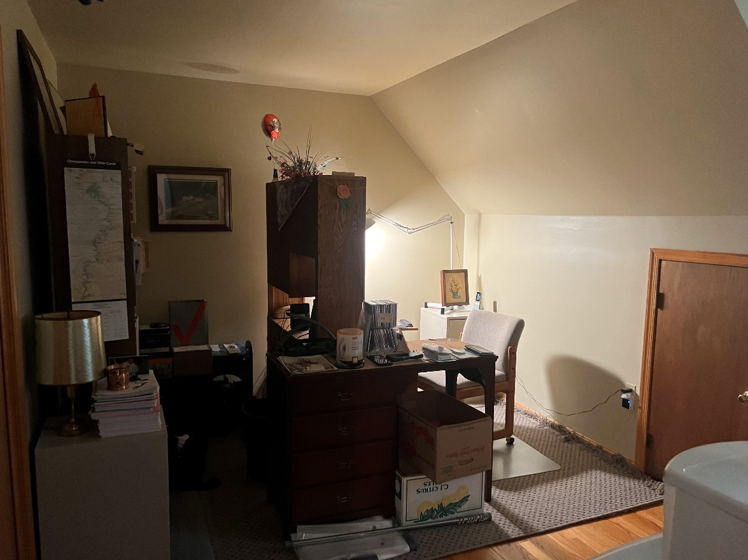

**SECOND LEVEL BEDROOM 2 (USED AS OFFICE)**

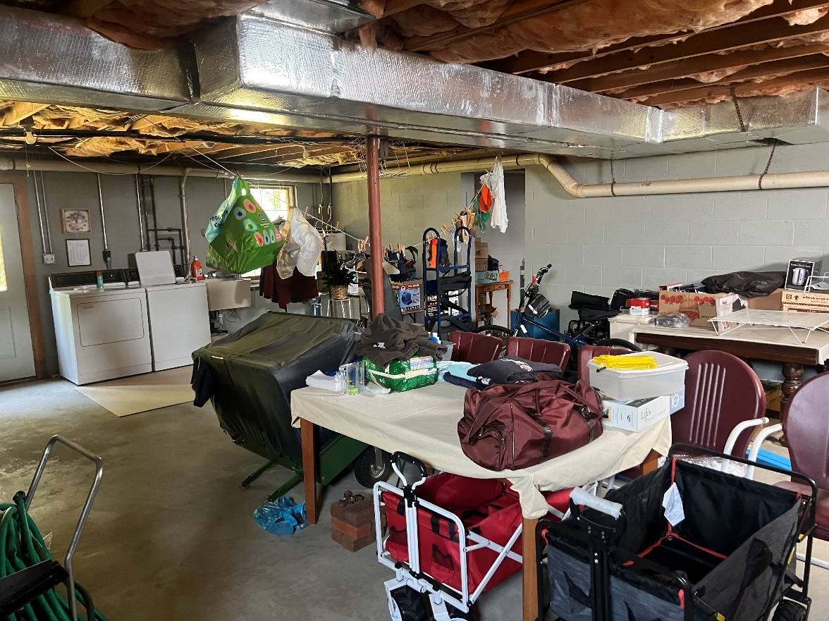

**BASEMENT MAIN AREA**

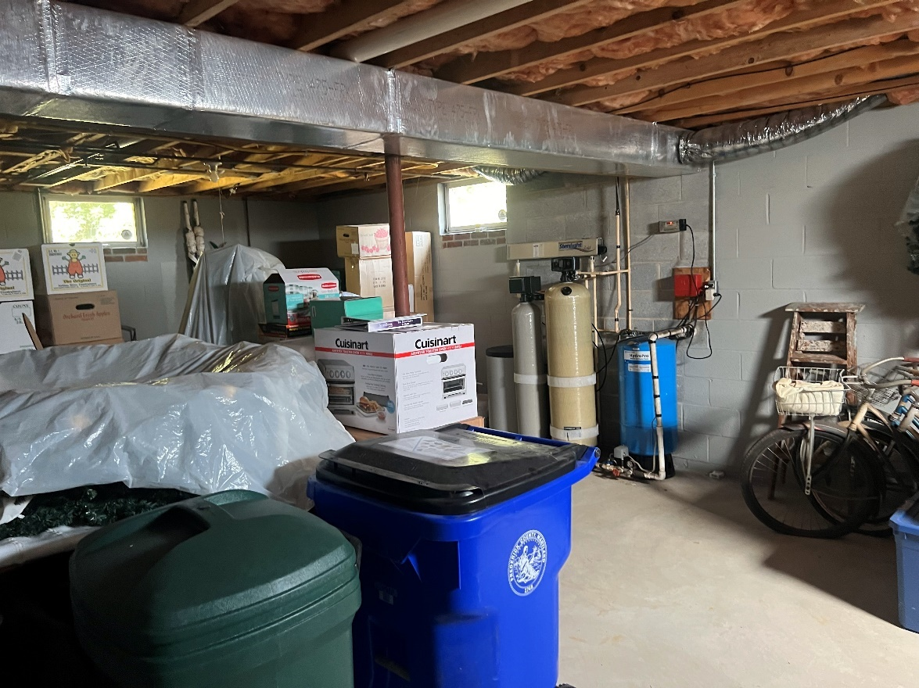

**BASEMENT BOILER ROOM**

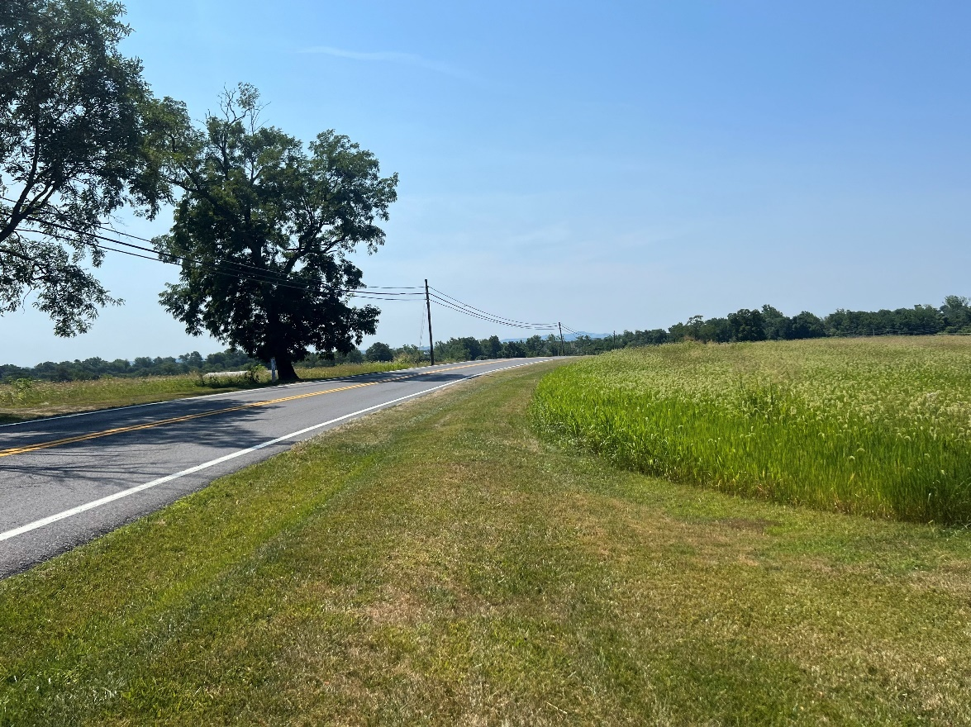

**YELLOW SPRINGS ROAD – FACING SOUTH**

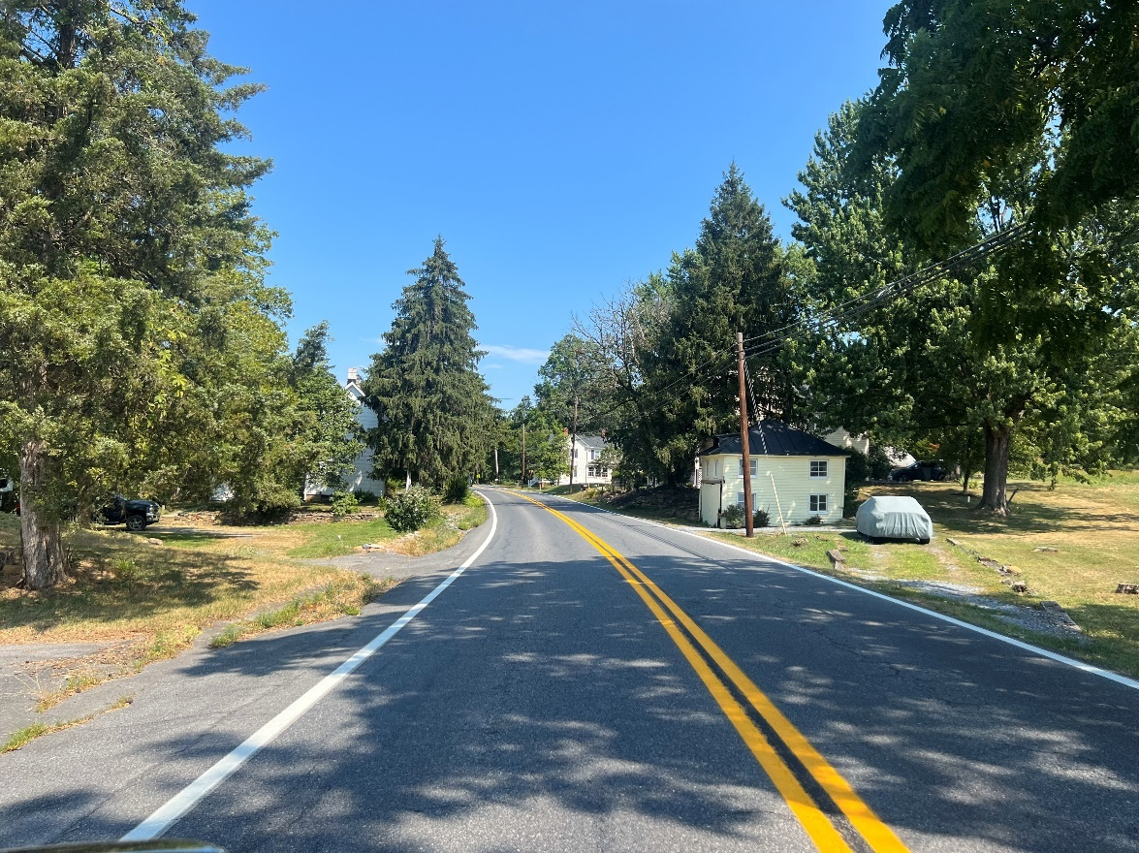

**YELLOW SPRINGS ROAD – FACING NORTH**

# HIGHEST AND BEST USE

Highest and best use may be defined as:

**Highest and best use***. The reasonably probable and legal use of vacant land or an improved property, which is physically possible, appropriately supported, financially feasible, and that results in the highest value.*

In the analysis of pertinent data, four criteria are applied in the following order to develop adequate support for the appraiser’s highest and best use determination:

1. Legally permissible
2. Physically possible
3. Financially feasible
4. Maximally productive

These criteria are generally considered sequentially; however, the tests of physical possibility and legal permissibility can be applied in either order, but they both must be applied before the tests of financial feasibility and maximum productivity.

The process for determining the highest and best use of a property has four main steps. The first two are applied in the analysis of highest and best use of the land or site as though vacant; the third and fourth steps are applied in the analysis of the highest and best use of the property as improved.

1. Determine the highest and best use of the site as though vacant.
2. Determine the ideal improvement for development of the site.
3. Compare the ideal improvement and the existing improvement.
4. Conclude whether the improvements should be maintained as is or be renovated, converted, or demolished.

I have presented the analysis of the site as though vacant and as improved in the following pages.

**Analysis Of The Site As Though Vacant**

By definition, the highest and best use of land as though vacant is among all reasonable, alternative uses, the use that yields the highest present land value, after payments are made for labor, capital, and coordination. The use of a property based on the assumption that the parcel of land is vacant or can be made vacant by demolishing any improvements.

This analysis helps to identify comparable properties and to identify the use that would produce maximum income to the land. The land's highest and best use as though vacant is a necessary part of deriving a land value estimate and is the basis for determining the potential of obsolescence (the highest and best use of the site as though vacant is different than the highest and best use as if improved).

There are four criteria for estimating the highest and best use of the subject property as though vacant: physical possibility, legal permissibility, financial feasibility, and maximum profitability.

|  |  |
| --- | --- |
| **Final Analysis** | Residential. |
|  |  |
|  |  |

**Analysis Of The Site As Improved**

By definition, the highest and best use of the property as improved is: the use that should be made of a property as it exists. An existing property should be renovated or retained as long as it continues to contribute to the total market value of the property, or until the return from a new improvement would more than offset the cost of demolishing the existing building and constructing a new one.

Highest and best use of a property as improved pertains to the use that should be made of an improved property in light of its improvements. Should it be replaced with a different type or intensity of use.

There are four criteria for estimating the highest and best use of the subject property as though improved: physical possibility, legal permissibility, financial feasibility, and maximum profitability.

|  |  |
| --- | --- |
| **Final Analysis** | Continued use as improved. |

**VALUATION**

# VALUATION METHODOLOGY

The valuation process is accomplished through specific steps; the number of steps followed depends on the nature of the appraisal assignment and the data available. The model indicates a pattern that can be used in any appraisal assignment to perform market research and data analysis, to apply appraisal techniques, and to integrate the results of these activities into an estimate of defined value.

Traditionally, appraisal techniques are the specific procedures within the three approaches that are applied to derive indications of real property value. Other procedures such as the use of inferential statistics and economic models also contribute to appraisals. One or more approaches to value may be used depending on their applicability to the particular appraisal assignment.

The ultimate goal of the valuation process is a well-supported value conclusion that reflects all of the factors that influence the market value of the property being appraised. To achieve this goal, an appraiser studies a property from three different viewpoints, which correspond to the three traditional approaches to value.

|  |  |
| --- | --- |
|  |  |
| **SITE VALUATION** | In the valuation process land value estimation is a separate step. The most reliable way to estimate land value is by sales comparison. When few sales are available, however, or when the value indications produced through sales comparison need additional support, other procedures may be used to value land. |
| **COST APPROACH** | A set of procedures through which a value indication is derived for the Fee Simple interest in a property by estimating the current cost to construct a reproduction of, or replacement for, the existing structure; deducting accrued depreciation from the reproduction or replacement cost; and adding the estimated land value plus an entrepreneurial profit. Adjustments may then be made to the indicated Fee Simple value of the subject property to reflect the value of the property interest being appraised. |
| **INCOME APPROACH** | A set of procedures through which an appraiser derives a value indication for an income-producing property by converting its anticipated benefits (cash flows and reversion) into property value. This conversion can be accomplished in two ways. One year’s income expectancy can be capitalized at a market-derived capitalization rate or at a capitalization rate that reflects a specified income pattern, return on investment, and change in the value of the investment. Alternatively, the annual cash flows for the holding period and the reversion can be discounted at a specified yield rate. |
| **SALES COMPARISON**  **APPROACH** | A set of procedures in which a value indication is derived by comparing the property being appraised to similar properties that have been sold recently, applying appropriate units of comparison, and making adjustments to the sale prices of the comparables based on the elements of comparison. The sales comparison approach may be used to value improved properties, vacant land, or land being considered as though vacant; it is the most common and preferred method of land valuation when comparable sales data is available. |

# Site Valuation

The first step in the cost approach is to estimate the value of the site as though vacant. The site valuation is performed to derive a value for the underlying land associated with the subject property. Typically, one of four different methods is used for the site valuation: Sales comparison; Allocation; Extraction; and Income capitalization.

Sales comparison is the most common technique for valuing the underlying site as though vacant, and it is the preferred method when comparable sales are available. To apply this method, data on sales of similar parcels of land is collected, analyzed, compared, and adjusted to provide a value indication for the site being appraised.

The allocation method is based on which site value is extracted from the sale price of an improved property by deducting the contributory value of the improvements, often estimated at their depreciated cost. The remaining value is the value of the site. Improved sales in rural areas are frequently analyzed in this way because the building and site improvements contribute little value in comparison to the underlying site value.

The various income capitalization procedures used to estimate land or site values rely on information that is often difficult for an appraiser to obtain. Therefore, these techniques are generally not used as primary valuation techniques except in special situations such as subdivision development analysis. The two most common income capitalization methods are the land residual technique and ground rent capitalization. The land residual technique is used almost exclusively in the highest and best use analysis to test the productivity of alternate uses of the site as though vacant. The ground rent capitalization procedure is useful when an analysis of comparable sales of leased land indicates a range of rents and capitalization rates.

Ultimately, we decided to analyze vacant residential land sales that had houses built after purchase in Frederick County. I used these sales to complete the valuation of the excess land.

The following chart displays the comparable sales and appropriate adjustments:



After consideration of the factors that influence market value, the opinion of value determined for the subject property is $1.50 per square foot. With the deduction of the flood zone area on the property, .51 acres, the total usable land size comes out to 5.78 acres or 251,777 square feet. Therefore: 251,777 square feet of usable land @ $1.50/Square Foot = $377,665.50; rounded to $380,000.

|  |  |
| --- | --- |
| **IMPROVED SALES ADJUSTMENT ANALYSIS – OVERALL SUMMARY** | |
| **TRANSACTIONAL ADJUSTMENTS** | |
| **Property Rights Conveyed** | No adjustments necessary. |
| **Financing** | No adjustments necessary. |
| **Sale Conditions** | No adjustments necessary. |
| **Expenditures After Purchase** | No adjustments necessary. |
| **Market Conditions** | No adjustments necessary. |
| **ELEMENTS OF COMPARISON** | |
| **Location** | No adjustments necessary. |
| **Zoning** | Sites 1, 2 and 3 were all superior, requiring negative adjustments. |
| **Topography/Shape** | Sales 2 and 3 were inferior, requiring positive adjustments. |
| **Development Status**  **Size** | No adjustments necessary.  Sales 1, 2 and 3 were inferior, requiring positive adjustments |
| **Utilities** | No adjustments necessary. |

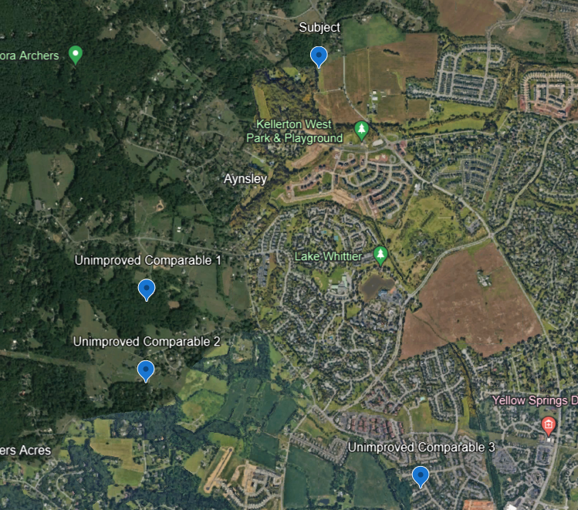

**SUMMARY OF COMPARABLE SALES**

|  |  |
| --- | --- |
| **UNIMPROVED SALE COMPARABLE** **1** | |
|  | |
| **TAX MAP** | |
| **Property Identification** | |
| Address | 8100 Mojave Ct. |
| City, State | Frederick, MD |
| Tax Account Identification | 21-437727 |
| Map/Grid/Parcel | 56/16/583 |
| Legal description | Lot 8 Blk B Sect 11 3.28 Acres Arrowood |
| **Sale Data** | |
| Grantor | Tanner Dainel Lawrence |
| Grantee | Bowersox Robert Bowersox Aimee |
| Sale date | 1/23/2023 |
| Deed Reference | 85/8 |
| Property rights | Fee Simple |
| Conditions of sale | Arms-Length |
| Time on market | Unknown |
| Sale price/SF | $275,000 |
| **Physical Data** | |
| Land size (acres) | 3.28 |
| Zoning | R1 |
| Utilities | Private |
| **Comments** | |
| At the time of sale, the property was vacant. After purchase, the owner built a residential home with 4,470 square feet of above grade living area. | |

|  |  |
| --- | --- |
| **UNIMPROVED SALE COMPARABLE 2** | |
|  | |
| **TAX MAP** | |
| **Property Identification** | |
| Address | 7818 B Old Receiver Rd |
| City, State | Frederick, MD |
| Tax Account Identification | 21-593083 |
| Map/Grid/Parcel | 56/22/68 |
| Legal description | Lot 2 Section 3 2.72 Acres Muskie Inc |
| **Sale Data** | |
| Grantor | Muskie Inc |
| Grantee | Steele Lucas Theo, Steele Jamie Lee |
| Sale date | 12/9/2021 |
| Deed Reference | 97/56 |
| Property rights | Fee Simple |
| Conditions of sale | Arms-Length |
| Time on market | Unknown |
| Sale price/SF | $150,000 |
| **Physical Data** | |
| Land size (acres) | 2.72 |
| Zoning | R1 |
| Utilities | Private |
| **Comments** | |
| At the time of sale, the property was vacant. After purchase, the owner built a residential home with 2,296 square feet of above grade living area. | |

|  |  |
| --- | --- |
| **UNIMPROVED SALE COMPARABLE 3** | |
|  | |
| **TAX MAP** | |
| **Property Identification** | |
| Address | 9016 Twin Ponds Ln |
| City, State | Frederick, MD |
| Tax Account Identification | 21-601290 |
| Map/Grid/Parcel | 47/23/19 |
| Legal description | Lot 5 Section 1 4.18 Acres Twin Ponds |
| **Sale Data** | |
| Grantor | Insignia Inc |
| Grantee | James Jennifer, Angela Murphy, Patrick Francis |
| Sale date | 6/10/2021 |
| Deed Reference | 104/136 |
| Property rights | Fee Simple |
| Conditions of sale | Arms-Length |
| Time on market | Unknown |
| Sale price/SF | $220,000 |
| **Physical Data** | |
| Land size (acres) | 4.18 |
| Zoning | R1 |
| Utilities | Private |
| **Comments** | |
| At the time of sale, the property was vacant. After purchase, the owner built a residential home with 2,436 square feet of above grade living area. | |

# COST APPROACH TO VALUE

Like the sales comparison and income capitalization approaches, the cost approach to value is based on market comparisons. In the cost approach, the appraiser analyzes the cost of the subject improvements by comparison to the cost to develop similar or exact improvements as evidenced by the cost of construction of substitute properties with the same utility as the subject property. The estimate of cost is adjusted for market-extracted losses in value caused by the age, condition, and utility of the subject improvements or for location problems. Next, the land value is added. The sum of the value of the land and the improvements is adjusted for the property rights conveyed based on market comparisons.

The principle of substitution, the underlying rationale of this approach, holds that no prudent person will pay more for a property than the price of a site and the cost of constructing, without undue delay, an equally desirable and useful property.

In the cost approach, the following steps are typically employed:

1. Estimate the value of the site as though vacant and available to be developed to its highest and best use.
2. Determine which cost basis is most applicable to the assignment: reproduction cost or replacement cost.
3. Estimate the direct (hard) and indirect (soft) costs of the improvements as of the effective appraisal date.
4. Estimate the appropriate entrepreneurial profit or incentive from analysis of the market.
5. Add the estimated direct costs, indirect costs, and entrepreneurial profit or incentive to arrive at the total cost of the improvements.
6. Estimate the amount of depreciation in the structure and, if necessary, allocate it among the three major categories:

* Physical deterioration
* Functional obsolescence
* External obsolescence

1. Deduct estimated depreciation from the total cost of the improvements to derive an estimate of their depreciated cost.
2. Estimate the contributory value of any site improvements that have not already been considered.
3. Add site value to the total depreciated cost of all the improvements to develop the market value of the property.
4. Adjust the value conclusion if any personal property (e.g., furniture, fixtures, and equipment) or intangible assets are included in the appraisal assignment. If necessary, this value, which reflects the value of the Fee Simple interest, may be adjusted for the property interest being appraised to arrive at the indicated value of the specified interest in the property.

Definitions of terms that may be used in the cost approach analysis include:

Breakdown method. *A method of estimating depreciation in which the total loss in the value of a property is estimated by analyzing and measuring each cause of depreciation (physical, functional, and external) separately.*

Cost approach. *A set of procedures through which a value indication is derived for the Fee Simple interest in a property by estimating the current cost to construct a reproduction of (or replacement for) the existing structure, including an entrepreneurial incentive, deducting depreciation from the total cost, and adding the estimated land value. Adjustments may then be made to the indicated Fee Simple value of the subject property to reflect the value of the property interest being appraised.*

Curable functional obsolescence. *An element of depreciation; a curable defect caused by a flaw in the structure, materials, or design, which can be practically and economically corrected.*

Curable physical deterioration. *A form of physical deterioration that can be practically and economically corrected as of the date of appraisal.*

Depreciation. *In appraising, a loss in property value from any cause; the difference between the cost of an improvement on the effective date of the appraisal and the market value of the improvement on the same date.*

Direct costs. *Expenditures for the labor and materials used in the construction of improvements; also called hard costs.*

Economic age-life method. *A method of estimating depreciation in which the ratio between the effective age of a building and its total economic life is applied to the current cost of the improvements to obtain a lump-sum deduction; also known as the age-life method.*

Economic life. *The period over which improvements to real property contribute to property value.*

Entrepreneurial incentive. *The amount an entrepreneur expects to receive for his or her contribution to a project. Entrepreneurial incentive may be distinguished from entrepreneurial profit (often called developer’s profit) in that it is the expectation of future profit as opposed to the profit actually earned on a development or improvement.*

External obsolescence. *An element of depreciation; a diminution in value caused by negative externalities and generally incurable on the part of the owner, landlord, or tenant.*

Functional obsolescence. *The impairment of functional capacity of a property according to market tastes and standards.*

Incurable functional obsolescence. *An element of depreciation; a defect caused by a deficiency or super-adequacy in the structure, materials, or design that cannot be practically or economically corrected.*

Incurable physical deterioration. *A form of physical deterioration that cannot be practically or economically corrected as of the date of appraisal.*

Indirect costs. *Expenditures or allowances for items other than labor and materials that are necessary for construction, but are not typically part of the construction contract. Indirect costs may include administrative costs; professional fees; financing costs and the interest paid on construction loans; taxes and the builder’s or developer’s all-risk insurance during construction; and marketing, sales, and lease-up costs incurred to achieve occupancy or sale. Also called soft costs.*

Physical deterioration. *The wear and tear that begins when a building is completed and placed into service.*

Physical life. *The total period a building lasts or is expected to last as opposed to its economic life.*

Quantity survey method. *A cost-estimating method in which the quantity and quality of all materials used and all categories of labor required are estimated and unit cost figures are applied to arrive at a total cost estimate for labor and materials.*

Reproduction cost. *The estimated cost to construct, at current prices as of the effective date of the appraisal, an exact duplicate or replica of the building being appraised, using the same materials, construction standards, design, layout, and quality of workmanship and embodying all the deficiencies, super-adequacies, and obsolescence of the subject building.*

Unit-in-place method. *A cost-estimating method in which total building cost is estimated by adding together the unit costs for the various building components as installed; also called the segregated cost method.*

Useful life. *The period of time over which a structure or a component of a property may reasonably be expected to perform the function for which it was designed.*

This analysis follows on the table below:

|  |  |  |  |  |
| --- | --- | --- | --- | --- |
| **REPLACEMENT COST – SINGLE-UNIT RESIDENCE** | | | | |
|  | | **VALUE** | **DETAIL** | |
| **Direct Cost** | | $415,833 | **Reproduction Rate Selection**  **Reference: Marshall and Swift Valuation Service**  **Section 12, Page 25/Class “D” – Good Quality**  SF Residence 2,584 Square Feet, Gross  Base Rate/Sq. Ft. $135.00  Sprinkler $5.25  Building Total $140.25  Refinements: Local Multiplier .99  Current Cost Multiplier .99  Shape .974  Cumulative Total .95  $140.25.25 x .95 = $133.24/GSFBA  **Building 2,584 Sq. Ft. @$133.24 = $344,292.16**  **Plus:**  Unfinished basement @ $29.93 x 2,038 = $60,987.15  Fireplace = $4,275  Balcony/covered rear porch @ $34.50 x 182 SF= $6,279  **Total Add Ons $71,541.14** | |
| **Indirect Cost/Ent. Profit** | | **$49,900** | Profit estimated at 10% of building costs; Indirect costs estimated at 2%. | |
| **Contingency** | | **$41,583** | Estimated at 10% of building costs. | |
| **TOTAL COST** | | **$507,316** |  | |
| **DEPRECIATION** | | | | |
| **Curable Physical Deterioration** | | $2,500 | The subject property does not currently have any curable physical deterioration. | |
| **Incurable Physical Deterioration** | | $0 | The subject property does not currently have any incurable physical deterioration. | |
| **Building Depreciation** | | $192,780 | This was estimated based on the age/life method which account for the building effective age (15 years) and expected life (40 years), this results in a 38% depreciation. | |
| **Total Depreciation** | **$195,280** | | |  |
| **REPLACEMENT COST – DETACHED GARAGE** | | | | |
|  | | **VALUE** | **DETAIL** | |
| **Direct Cost** | | $44,092.84 | **Reproduction Rate Selection**  **Reference: Marshall and Swift Valuation Service**  **Section 12, Page 35/Class “C” – Low Cost (-) Quality**  Residential Garage - Detached Area 864 Square Feet, Gross  Base Rate/Sq. Ft. $45.75  Building Total $45.75  Refinements: Local Multiplier .99  Current Cost Multiplier .99  Cumulative Total .98  $45.75 x .98 = $47.56/GSFBA  Building 864 Sq. Ft. @$47.56 = $41,091.84  Plus estimated cost per overhead garage door (3) -- $3,000 | |
| **Indirect Cost/Ent. Profit** | | **$5,291.14** | Profit estimated at 10% of building costs; Indirect costs estimated at 2%. | |
| **Contingencies** | | **$4,409.28** | Estimated at 10% of building costs. | |
| **TOTAL COST** | | **$53,793.26** |  | |
| **DEPRECIATION** | | | | |
| **Curable Physical Deterioration** | | $500 | The subject property does not currently have any curable physical deterioration. | |
| **Incurable Physical Deterioration** | | $0 | The subject property does not currently have any incurable physical deterioration. | |
| **Building Depreciation** | | $26,896.63 | This was estimated based on the age/life method which account for the building effective age (15 years) and expected life (30 years), this results in a 50% depreciation. | |
| **Total Depreciation** | **$**26,896.63 | | |  |
| **Contributory Value** | **$26,896.63** | | | **Rounded to $27,000** |

An analysis of the cost approach can be found on the following page.



# INCOME CAPITALIZATION APPROACH

In the income approach, the present value of the future benefits of property ownership is measured. A property’s income and resale value upon reversion may be capitalized into a current, lump-sum value. There are two methods of income capitalization: direct capitalization and yield capitalization. In direct capitalization, the relationship between one year’s income and value is reflected in either a capitalization rate or an income multiplier. In yield capitalization, the relationship between several years’ stabilized income and a reversionary value at the end of a designated period is reflected in a yield rate. The most common application of yield capitalization is discounted cash flow analysis.

In this appraisal report, the direct capitalization method of income capitalization was used. In direct capitalization, a single year’s net operating income is divided by an overall capitalization rate to arrive at an indication of value. The general formula for the income approach is as follows:

1. Estimate the potential gross income (PGI).

2. Estimate the vacancy and collection loss.

3. Subtract the vacancy and collection loss from the potential gross income to derive the effective gross income.

4. Estimate the total operating expenses for the subject and deduct them from the effective gross income to derive net operating income (IO).

5. Estimate an overall capitalization rate (RO).

6. Divide the net operating income by the overall capitalization rate to derive a value indication by the income capitalization approach.

Definitions that may be used in the income capitalization approach analysis are as follows:

Direct capitalization. *A method used to convert an estimate of a single year’s income expectancy into an indication of value in one direct step, either by dividing the net income estimate by an appropriate capitalization rate or by multiplying the income estimate by an appropriate factor. Direct capitalization employs capitalization rates and multipliers extracted or developed from market data. Only a single year’s income is used. Yield and value changes are implied but not identified.*

Effective gross income (EGI). *The anticipated income from all operations of the real property after an allowance is made for vacancy and collection losses and an addition is made for any other income.*

Income capitalization approach. *A set of procedures through which an appraiser derives a value indication for an income-producing property by converting its anticipated benefits (cash flows and reversion) into property value. This conversion can be accomplished in two ways. One year’s income expectancy can be capitalized at a market-derived capitalization rate or at a capitalization rate that reflects a specified income pattern, return on investment, and change in the value of the investment. Alternatively, the annual cash flows for the holding period and the reversion can be discounted at a specified yield rate.*

Net operating income (IO). *The actual or anticipated net income that remains after all operating expenses are deducted from effective gross income but before mortgage debt service and book depreciation are deducted.*

Operating expenses. *The periodic expenditures necessary to maintain the real property and continue production of the effective gross income, assuming prudent and competent management.*

Potential gross income (PGI). *The total income attributable to real property at full occupancy before vacancy and operating expenses are deducted.*

Vacancy and collection loss. *A deduction from potential gross income (PGI) made to reflect income reductions due to vacancies, tenant turnover, and nonpayment of rent; also called vacancy and credit loss or vacancy and contingency loss. Often vacancy and collection loss is expressed as a percentage of potential gross income and should reflect the competitive market. Its treatment can differ according to the interest being appraised, property type, capitalization method, and whether the property is at stabilized occupancy.*

This approach was not relevant in solving the appraisal problem and was abandoned.

# SALES COMPARISION APPROACH

The sales comparison approach is defined as:

Sales comparison approach. *The process of deriving a value indication for the subject property by comparing market information for similar properties with the property being appraised, identifying appropriate units of comparison, and making qualitative comparisons with or quantitative adjustments to the sale prices (or unit prices, as appropriate) of the comparable properties based on relevant, market-derived elements of comparison.*

The elements of comparison are defined as:

Elements of comparison. *The characteristics or attributes of properties and transactions that cause the prices of real property to vary; include real property rights conveyed, financing terms, conditions of sale, expenditures made immediately after purchase, market conditions, location, physical characteristics, and other characteristics such as economic characteristics, use, and non-realty components of value.*

In the sales comparison approach, the value of a property is estimated by comparing it with similar, recently sold properties in the surrounding or competing area. Inherent in this approach is the principle of substitution, which holds that when a property is replaceable in the market, its value tends to be set by the cost of acquiring an equally desirable substitute property, assuming that no costly delay is encountered in making the substitution.

Through the analysis of sales of verified arm’s-length transactions, market value and price trends are identified. The sales utilized are comparable to the subject in physical, functional, and economic characteristics. The basic procedure is as follows:

1. Identify the most recent relevant sales from which to select and analyze truly comparable sales, with consideration given to the date of sale.
2. Identify any changes in economic conditions between the date of sale and the date of value.
3. Calculate the cash equivalent price for any sale that includes favorable financing.
4. Reduce the sale price to a unit of comparison such as the sale price per square foot or sale price per unit.
5. Make appropriate adjustments to the prices of the comparable sale properties for differences in the relevant elements of comparison.
6. Interpret the results to derive a value indication from the sales comparison approach.

***Sales Comparison Approach***

During the preparation of this report, several sales of similar residential properties were analyzed. Ultimately, four sales were selected to form an opinion of value for this appraisal report -- each were similar to the subject property in physical characteristics. The following is a "Sales Adjustment Chart," which summarizes key aspects of each sale relative the subject property. **The opinion of value using the Sales Comparison Approach is $700,000 as of June 11, 2024.**



|  |  |
| --- | --- |
| **Adjustments** | |
| Location | Sales 1, 2 and 3 had inferior locations, requiring positive adjustments. |
| Above Grade Bedrooms | Sales 1, 2 and 3 all had more bedrooms, requiring positive adjustments. |
| Bathrooms | Not required. |
| Below Grade Finish | Sales 2 and 3 had more bathrooms, requiring positive adjustments. |
| Pool | Not required. |
| Heating/Cooling | Not required. |

|  |  |
| --- | --- |
| **IMPROVED** **Sale Number: 1** | |
| **Property Address**  4704 Rocky Mills Drive, Frederick, Maryland  **Legal Description**  Tax ID: 23-450550  Land: 4.13 acres  Above grade SF: 2,814  Below grade SF: 1,395  Below grade SF finished: 500  Bedrooms: 4  Full Baths: 2  Half Baths: 1  Garage: Yes, two spaces  Constructed in 1993  Frederick County, Maryland  **Transaction Summary**  Sale Date: 6/7/2024  Price: $710,000  Grantors: Robinson John M & Ann K  Grantees: Schlosberg Anna Elizabeth Santanilla Jesus Sterling  Days on Market: 83  **Comments**  Basement has potential for fifth bedroom to be added. The owner’s suite has separate shower and sunken tub. | **COMPARABLE PROPERTY PHOTO** |
| **PROPERTY TAX MAP** |

|  |  |
| --- | --- |
| **IMPROVED** **Sale Number: 2** | |
| **Property Address**  3711 Buffalo Road, New Windsor, Maryland  **Legal Description**  Tax ID: 19-386317  Land: 4.05 acres  Above grade SF: 2,911  Below grade SF: 936  Below grade SF finished: 936  Bedrooms: 4  Full Baths: 4  Half Baths: 1  Garage: Yes, two spaces  Constructed in 1978  New Windsor, Maryland  **Transaction Summary**  Sale Date: 3/29/2024  Price: $690,000  Grantors: Sipe George Philip III  Grantees: Pleet Kathleen Lummis Michael  Days on Market: 31  **Comments**  Extra large kitchen with granite counters and a walk-in pantry. Multiple dining spaces. Multiple fireplaces with exposed brick. Finished basement that is freshly painted and newly carpeted. | **COMPARABLE PROPERTY PHOTO** |
| **PROPERTY TAX MAP** |

|  |  |
| --- | --- |
| **IMPROVED** **Sale Number: 3** | |
| **Property Address**  8301-A Mapleville Road, Mount Airy, Maryland  **Legal Description**  Tax ID: 19-389057  Land: 3.31 acres  Above grade SF: 2,812  Below grade SF: 1,092  Below grade SF finished: 0  Bedrooms: 4  Full Baths: 3  Half Baths: 1  Garage: Yes, four spaces  Constructed in 1998  Mount Airy, Maryland  **Transaction Summary**  Sale Date: 11/3/2023  Price: $755,000  Grantors: Horn Matthew D  Grantees: Brol Christopher Apanavage  Days on Market: 83  **Comments**  Scraped flooring throughout the first floor. Owner’s suite has updated bathroom. Two-story family room features a floor-to-ceiling stone fireplace. Kitchen is updated with granite countertops. | **COMPARABLE PROPERTY PHOTO** |
| **PROPERTY TAX MAP** |

**LOCATION MAP: SUBJECT PROPERTY AND COMPARABLE SALES**

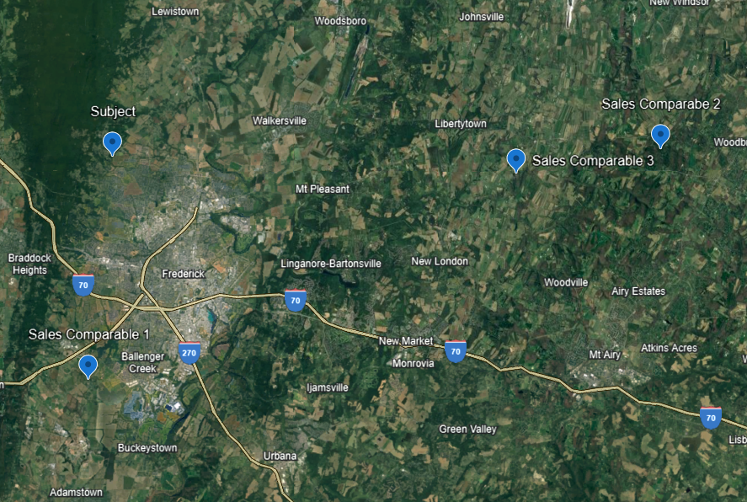

# RECONCILIATION OF VALUE INDICATIONS

The Sales Comparison and Cost Approach to value are relevant to this appraisal assignment. There were several relevant sales – current and verified -- available for me to ascertain market support for all adjustments. During the creation of this report, I interviewed several market participants – brokers, property managers, investors, developers – about this property and the sales reflected in this report to ensure that each was relevant with the other. The range of adjusted sale prices are within the range observed in the market and I’m confident in my value opinion. The conclusion reached using these approaches are consistent with one another.

I’ve reviewed the entire appraisal and have confirmed that I’ve used relevant data available for this assignment with accepted analytic techniques that are generally understood by investors in this marketplace My value opinion is the current market or “as-is” of the fee simple interest in the subject property. Given that the entire subject property primarily is used by the owner, this is appropriate.

|  |  |
| --- | --- |
| **VALUATION** | |
| Retrospective market value as of June 11, 2024 | Site Valuation $380,000  Cost Approach $715,000  Sales Comparison Approach $705,000  Income Capitalization Abandoned  **Reconciled Value $710,000** |

**ADDENDUM**

***MICHAEL PATRICK PUGH, MAI***

***APPRAISAL QUALIFICATIONS***

**LENGTH OF EXPERIENCE**

Seventeen years devoted to Real Estate Appraisal

19 Years Secondary Mortgage Market: Fannie Mae & Freddie Mac

**PROFESSIONAL ATTAINMENTS**

Designated Member of the Appraisal Institute (Member Number: 349530)

Certified General Real Estate Appraiser

* State of Maryland (License No. 04-29481)
* Washington, District of Columbia (License No. GA0000137)

**EDUCATION**

Auburn University: Bachelor of Arts; International Relations/Political Science

Mount St. Mary's University: Masters of Business Administration – Honors Graduate

**APPRAISAL INSTITUTE EDUCATION**

|  |  |
| --- | --- |
| * Residential Valuation * Real Estate Appraisal Principals * Real Estate Appraisal Procedures * Uniform Standards of Professional Appraisal Practice * General Appraiser Market Analysis and Highest and Best Use * Real Estate Finance, Statistics, and Valuation Modeling * General Appraiser Income Approach/Part One * General Appraiser Income Approach/Part Two * Client Perspectives on Real Estate Appraisal * Condemnation Appraisal Principles * Business Practices and Ethics General Appraiser Site Valuation and Cost Approach | * General Appraiser Sales Comparison Approach * General Appraiser Report Writing and Valuation Analysis * Advanced Sales Comparison and Cost Approach * Advanced Income Approach * Advanced Applications * MAI Comprehensive Examination * Supervisory Appraiser/Trainee Appraiser Course * Rates and Ratios: GIMs, OARs, and DCF * Analyzing Operating Expenses * Appraising Convenience Stores * Demonstration of Knowledge Report * 2016-2017 USPAP Update * 2018-2019 USPAP Update * 2020-2021 USPAP Update * 2022-2023 USPAP Update |

**APPRAISAL CLIENTS – SAMPLE**

|  |  |
| --- | --- |
| * ACNB Bank * Ameriserv Trust and Financial Services * BB&T Bank * Carroll Community Bank * Community Bank of the Chesapeake * Comstar Federal Credit Union * County First Bank * First United Bank and Trust * Middletown Valley Bank * Woodsboro Bank * Sandy Spring Bank * SonaBank | * City of Frederick * City of Takoma Park * Garrett County Government * Frederick County Government * Maryland National Capital Park and Planning * Montgomery County Housing Authority * Ralph J. Duffie, Inc. * Town of Mt. Airy * Way Station, Inc. * WLR Investment Group, Inc. * YMCA of Frederick County * Other Clients: Attorneys, Real Estate Investors, Corporations. |

**SCOPE OF EXPERIENCE**

Apartment, Churches, Special Purpose, Mixed-Use, Retail, Office Buildings, Office Condominiums, Single-Family Residences, Retail, Vacant Land (residential, agricultural, commercial, industrial), Warehouse/Flex, Industrial, Manufacturing, and Farms.

**PURPOSE OF MOST APPRAISALS**

Acquisition/disposition, mortgage lending, estate planning and settlement, litigation, condemnation, easement valuation.

**JURISDICTIONS**

Washington D.C. and Maryland. Maryland Counties: Allegany, Anne Arundel, Baltimore, Baltimore City, Charles, Calvert, Carroll, Frederick, Garrett, Howard, Montgomery, Prince George’s, St. Mary’s, Washington.





1. Source: The Dictionary of Real Estate Appraisal, Appraisal Institute, Sixth Edition, 2015
2. Source: FIRREA
3. Maryland Department of Labor, 2022 statistics.
4. U.S. Census Quickfacts, January 2024.
5. The Appraisal of Real Estate; 14th Edition; 2015
6. Federal Open Markets Committee statement September 20, 2023.
7. [1] Federal Reserve Bank of Richmond: Maryland Economic Snapshot, November 2022